Summary of Household Research

Powell-Division households are likely to be transit-dependent (at least somewhat), and are already significantly pressured by housing prices. The corridor is perhaps 18,000 rental units short of adequate affordable housing stock. We are able to segment by income groups to see that households making 30-50% of area median family income are the most housing cost-burdened, and rental units affordable to that income range are likely to be leased by higher income households. (further illustrated by the relatively lower rates of cost-burden for households earning 50-80% of area median income). This suggests some strategies for alleviating housing supply pressures at these income ranges, as well as the households at most risk for displacement if prices rise with new investments in transit.

At the same time, the rental housing stock along the corridor is “precarious”—a term used to mean at risk of conversion, demolition, or serious deterioration. Many housing units are already in poor condition. Over the past 5 years, there have been 50 buildings (with over 1,300 units) sold. These buildings were overwhelmingly “2 star” rated (just above obsolete) and had moderate and low rents. Most were small buildings (under 10 units). We will continue to analyze sales, for sale properties, and new construction data and add interview data with property owners and managers to assess likelihood of sale and conversion of existing affordable units.

Reference: Geographic Units

The geographic segments used in the analysis are followed by the report from the Metro (Powell-Division Transit and Development Project Opportunities & Constraints, 2014). While the segments from the report were originally 8 segments, this analysis employed an aggregated segments using the original one from the report in order to better align with the Census Tract boundaries.

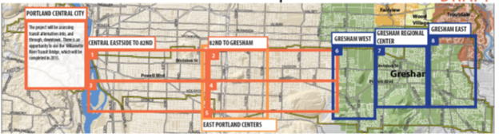
Figure 1. Original proposed segments along the corridor by Metro (2014)
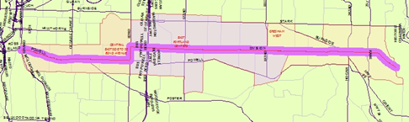
Figure 2. Segments along the corridor in the analysis

Central East Portland: Central Eastside to 82nd Ave
East Portland: 82nd to Gresham (182nd Ave)
Gresham West: 182nd Ave to the end of the corridor (Gresham)

Snapshots: Vulnerability, Precarious Housing, Cost Burden and Housing Mismatch

1) Vulnerability

Vulnerable households are clustered past E. 82nd Ave. The close-in section of the transit corridor does not look markedly different from the rest of Portland, but East Portland and Gresham sections have more vulnerable populations than Portland-Multnomah County as a whole.

These neighborhoods of lower-cost housing include substantial populations we expect to be transit-dependent or transit-using.

 | Multnomah | Portland | Corridor | Central Eastside | East Portland | Gresham West
Educational Attainment | 40.3% | 44.4% | 24.3% | 45.5% | 15.7% | 17.8%
Median Income | 52,845 | 53,230 | 43,574  (82.5%) | 54,190  (102.5%) | 38,083  (72.1%) | 42,423  (80.3%)
People with Disabilities | 12.6% | 12.1% | 14.6% | 11.5% | 15.8% | 15.0%
Elderly | 20.3% | 19.5% | 22.6% | 17.7% | 24.8% | 24.3%
Single Female Headed Households | 10.8% | 9.9% | 15.1% | 9.7% | 17.5% | 16.7%
Large Family with low incomes  (Renters) | 54.7% | 55.4% | 57.3% | 71.8% | 57.6% | 53.9%
Does not Speak English well | 9.3% | 8.9% | 16.4% | 7.2% | 23.3% | 10.5%
Data Source: ACS 2010-2014 5 year Estimates, 2008-2012 CHAS

2) Precarious Housing (Dwelling Units)

Compared to the overall housing stock in the county, there are more small multifamily housing units in the corridor—multifamily buildings with fewer than 10 units.

Based on the conditions field study conducted by BPS, these small multifamily buildings may be in poor condition. In the station area target zones, surveyors found 483 units in duplex, triplex, quad buildings and manufactured housing that are in poor condition. In the 162nd and Division area there were 43 percent of all units rated poor; in Division Midway it was 29%. These units are older and may not be capitalized sufficiently to provide repairs without displacing tenants.

Precarious housing indicators
 | Multnomah | Portland | Corridor | Central Eastside | East Portland | Gresham West
Renter Occupied | 46.3% | 47.2% | 52.7% | 51.4% | 51.5% | 57.0%
Single family | 56.1% | 56.1% | 53.2% | 59.0% | 55.2% | 40.9%
Multi-Family Buildings, fewer than 10 units | 15.8% | 15.3% | 21.6% | 22.9% | 18.7% | 26.6%
Multi-Family Buildings, more than 20 units | 16.3% | 18.0% | 11.3% | 7.8% | 12.1% | 14.1%
Built before 1970 | 55.1% | 62.1% | 48.6% | 71.8% | 47.7% | 20.5%
Overcrowded  (occupants per room >1) | 3.2% | 3.0% | 5.7% | 1.9% | 8.1% | 5.3%
Data Source: ACS 2010-2014 5 year Estimates

According to analysis of CoStar data on multifamily property sales, over the past 5 years, there have been 50 buildings (with over 1,300 units) sold. These buildings were overwhelmingly “2-star” rated (just above obsolete) and had moderate and low rents. Most were small buildings (under 10 units).

Multifamily buildings sold 2011-2016 in corridor
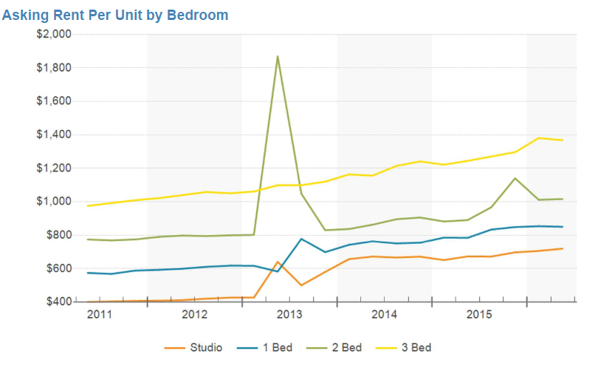

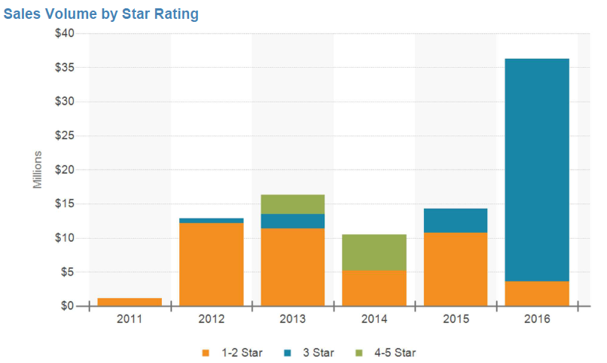

3) Cost Burden
Households that are already cost-burdened--that is, paying more than 30% of their monthly income on housing--are more likely to be displaced by rising housing costs with redevelopment on the corridor. Cost burdens are greater than citywide figures for renters along Powell-Division, although the proportion of cost-burdened renters declines with moves eastward along the corridor.

The cost burden of the low-income households (below 80% AMFI) is much higher than that of all income level. Regardless of tenure status, the households living in the corridor are likely to remain cost burdened. 69.8% of low-income renters are cost burdened in the corridor. Out of 63,851 cost burdened renters in the County, 27% are concentrated in the corridor.

Cost Burdened Households By Income
 |  | Multnomah | Portland | Corridor | Central Eastside | East Portland | Gresham West
Owner | All Income | 33.1% | 33.3% | 35.2% | 31.4% | 39.8% | 32.4%
 | Low Income | 67.5% | 68.3% | 66.4% | 68.9% | 65.9% | 65.2%
Renter | All Income | 49.5% | 49.2% | 53.1% | 48.9% | 55.7% | 53.2%
 | Low Income | 69.6% | 69.8% | 69.8% | 69.6% | 69.8% | 69.8%
Source. 2008-2012 CHAS, this table defines low-income households as those earning less than 80% of HAMFI.

Number of Cost Burdened Households with Low-income (<80% AMFI)
 | Multnomah | Portland | Corridor | Central Eastside | East Portland | Gresham West
Owner | 30,283 | 24,447 | 7,540  (24.9%) | 1,695 | 3,937 | 1,908
Renter | 63,851 | 52,546 | 17,504  (27.4%) | 4,425 | 8,069 | 5,010
Source. 2008-2012 CHAS

Racial equity impacts

Looking at renter households by race at different locations also provides information about racial equity impacts of potential gentrification. Black renters have very high cost burdens, more so than elsewhere in the city; the gap between cost burden in Gresham and the citywide average is 18 percent. Asian renter households have far greater cost burdens in the Jade district than they do citywide (by 20 percent). Latino households who rent are most burdened in East Portland (8 percent higher than the average for Latino cost burden).

Cost Burdened households by race/ethnicity
 | Multnomah | Portland | Corridor | Central Eastside | East Portland | Gresham West
White | 47.3% | 46.5% | 50.7% | 48.0% | 49.5% | 55.0%
Black | 61.0% | 61.0% | 67.0% | 55.0% | 68.7% | 78.6%
Asian | 48.4% | 48.4% | 59.8% | 52.9% | 64.7% | 47.9%
Native American | 58.2% | 56.2% | 64.5% | 54.3% | 79.9% | 60.9%
Pacific Islander | 70.0% | 77.2% | 58.0% | 100.0% | 58.6% | 56.0%
Hispanic | 55.4% | 58.0% | 56.8% | 50.3% | 66.7% | 46.7%
Others | 46.9% | 47.0% | 42.7% | 53.2% | 46.1% | 30.1%
Source. 2008-2012 CHAS

4) Housing Mismatch
There are already substantial shortages of housing for low incomes along the corridor. This supply shortage is exacerbated when households live in units that are priced for lower-income households’ affordability. This crowding out of lower-income households is most prevalent in units that are affordable to households making 30-50% of the area median family income. Over half the units affordable to these very low-income households are inhabited by households with higher incomes.

Number of Affordable Rental Housing Units
 | Multnomah | Portland | Corridor | Central Eastside | East Portland | Gresham West
Number of RHU | 107,606 | 87,219 | 29,869  (27.8%) | 8,145 | 13,045 | 8,679
Source. 2008-2012 CHAS, affordable rental housing units are regarded as those having rental rates below 80% of RHUD.

While affordable units in the corridor accounts for 28% of units in the County, 34% of those affordable in the corridor are taken by higher income households.

Housing Mismatch. (% of units affordable at an income level, occupied by higher income households)

 | Multnomah | Portland | Corridor | Central Eastside | East Portland | Gresham West
Affordable  RHU | 35.3% | 35.7% | 34.0% | 40.2% | 30.9% | 32.8%
RHUD<30 | 35.8% | 33.1% | 34.4% | 24.5% | 36.1% | 42.9%
30<RHUD<50 | 41.6% | 41.4% | 44.9% | 54.2% | 40.7% | 44.0%
50<RHUD<80 | 33.0% | 34.1% | 29.9% | 38.2% | 25.3% | 28.4%
Source. 2008-2012 CHAS,The estimates of this table indicates the percentage of housing units that are taken by higher income households.

One would be focusing new supply at 60-80% AMI to try to induce moves up the housing ladder. It's not the deepest need but it's more likely to pencil for developers with medium subsidy (like the LTE). Another is to get to these 2-star properties and preserve with rental restrictions at 30-50% which is likely what they're actually renting at now. Prevent some from selling to new owners who might upgrade to as high as the market will bear in the neighborhood.

