Transit-oriented development and gentrification literature review
New transit service is often sold as attracting development and increasing property values. As transit changes the accessibility of an areas, it becomes more attractive for investment. Transit investment leverages development investment of greater than $1 per $1 of transit investment (Hook et al, 2013). Nelson and Ganning (in progress) connect bus rapid transit investment with increased jobs and property values. Of course, transit also improves mobility and access for residents in transit-oriented development; providing more access to jobs and needed services. Transit-oriented development (TOD) can reverse the isolation of poverty and contribute to climate change improvements—if affordable housing is included in TOD (Gauthier 2014). Indeed, new transit investments can be a double-edged sword for disadvantaged communities (e.g. those included in environmental justice and Title VI protected classes). However, there is also the potential for transit-oriented development to spur gentrification and displacement if affordable housing is lost due to new investment and in-movers with higher incomes. Understanding transit corridor conditions and change with new infrastructure is important for learning how to mitigate negative effects and support inclusive communities with access to transit for lower-income households.
The existing literature suggests that new transit investments can create serious affordable housing problems for the very residents who depends most on transit: lower-income households and people of color. Public investments—sometimes even just the announcement of a planned investment—increase the investment potential of a neighborhood. When the city signals its commitment to place-making in a particular neighborhood through improvements to the built environment and development incentives, it decreases the risk of investment. The private market will respond by making capital available and increasing development activities. Additionally, as the public sector improves neighborhood access, infrastructure, and amenities, the neighborhood becomes more desirable and demand to live there by higher-income households increases. When public investments are made in neighborhoods where markets are already heating up, it can increase the intensity of the change and exacerbate displacement. Studies in the Bay Area found involuntary displacement due to the construction of new rail stations as rent premiums were charged for transit access. Chapple (2009) found that gentrifying neighborhoods were twice as likely to be near transit.
Gentrification in transit-oriented developments has a wide range of consequences. First, decreased neighborhood diversity can have a number of negative impacts as concentrated poverty increases in a region—both for regional economic health and for families’ social and economic futures. Involuntary housing displacement is disruptive. Second, as Pollack et al (2010) find, wealthier in-movers to TOD neighborhoods actually drive more and use transit less—leading to declines in transit share of commute modes in over half the transit-rich neighborhoods they studied. This means that transit ridership is not supported and climate change improvements are not realized. Third, as lower-income households are displaced, low-earning workers lose connections to jobs, either in the TOD itself or accessed via new transit (Puget Sound Sage 2012). Yet, when TOD is equitable, it can have very positive impacts, as reported by the Partnership for Sustainable Communities in Cleveland, where a bus rapid transit connects low income residents with strategic job locations, and housing and communities have been stabilized and affordability preserved.

A challenge for considering whether a new Bus Rapid Transit (BRT) system will have substantial neighborhood gentrification effects is that most research on this topic is about fixed rail, and there are fewer BRT systems in the U.S. BRT can be difficult to define because of the wide range of difference of various BRT systems currently in operation (Wright and Hook, 2007, p. 13). However, the minimum requirements for a transit system to be considered a BRT by the Institute for Transportation Development Policy are that it contains each of these five elements: “dedicated right-of-way, busway alignment, off-board fare collection, intersection treatments, and platform-level boarding” (ITDP, 2016a, p. 26).
BRT systems are becoming increasingly popular flexible, low-cost alternative to light-rail and other fixed guideway transit systems. The initial BRT investment cost and maintenance cost can be significantly cheaper than light rail, and because BRT vehicles are not attached to a permanent railway they are able to drive away from their normal route to provide additional service. “BRT systems will typically cost 2 to 20 times less than a light rail transit (LRT) system and 10 to 100 times less than a metro system” (Write and Hook, 2007, p. 11).
Because they are affordable and effective at improving transit speeds, BRT systems have been popular in large, highly congested cities of developing countries. Highly-rated, Gold-Standard BRT systems have been developed in cities like Curitiba, Rio de Janeiro, and Belo Horizonte, Brazil; Guangzhou, China; Botoga, Columbia; Guadalajara, Mexico; Lima, Peru; and Guatemala City, Guatemala (ITDP 2016b). There are BRT systems currently operating in over two hundred cities worldwide (http://brtdata.org/).
Cities in the United States have also invested in BRT, but at a lower rate. There are BRT systems currently located in twenty US cities (BRTData.org, 2016). The first BRT system in the United States was launched in 1977, soon after the world’s first BRT system in Curitiba, Brazil in 1974 (Nelson and Ganning, 2015, p. 25). The next BRT systems in the US weren’t developed until decades later. The MAX BRT in Las Vegas was launched in 2004 and the Orange Line in Los Angeles in 2005 (Nelson and Ganning, 2015, p. 25). The Healthline BRT in Cleveland (ITDP 2016b) and the CTfastrak in Hartford (ITDP, 2016a, p. 23) are the two most highly rated BRT systems in the US, receiving the Silver-Standard from the Institute for Transportation Development Policy. The United States has yet to build a Gold-Standard BRT.
Several studies from outside the United States indicate that BRT station areas incur land value and rent premiums on residential and commercial properties (Nelson and Ganning, 2015; Mulley et al., 2016). In literature reviews by Nelson and Ganning (2015) and Mulley et al. (2016), many instances of land value premiums are found near BRT station areas in large cities in the United States, Canada, Columbia, China, and South Korea. Slight premiums for property near BRT stations were found in Brisbane, Australia (Mulley et al. 2016, p. 51). In a study of BRT systems in Cleveland, Eugene-Springfield, Kansas City, Las Vegas, and Pittsburgh, significant premiums for asking office rents, on the order of “14 to 31 percent of the mean,” were found within 0.50 mile of BRT station areas (Nelson and Ganning, 2015, p. 73).
Recent studies have also found that BRT stations in the US incur premiums on residential and commercial property with proximity to BRT station areas comparable to premiums incurred by light-rail transit systems. Tables adapted from the literature reviews of Rodriguez and Mojica (2009) and Perk and Catala (2009) are shown in the appendix at the end of this document and display that most LRT transit station areas incur property value premiums – both of these studies indicate BRT station area premiums that are comparable to LRT.
In a literature review conducted by Nelson and Ganning (2015), the authors cite Thole and Sumus (2009) who say that “…there are no apparent differences between the land use incentives offered by cities for BRT versus LRT projects” (p. 55). In the same literature review, Nelson and Ganning (2015) find that “…BRT can be as influential as rail systems in encouraging urban redevelopment (Cervero, 2013; Cervero and Dai, 2014)” (p. 55).
Transportation cost savings are thought to drive residential property value increases with proximity to BRT station areas (Nelson and Ganning, 2015, p. 89). Nelson and Ganning (2015) reference Higgins and Kanaroglou (2015) in their assertion that transportation cost savings are capitalized into property values near station areas (p. 89). In an analysis of 12 BRT lines operating in the U.S. in 2010, Nelson and Ganning (2015) find that “…household transportation costs as a share of income increases with respect to distance from BRT stations to about eight miles away” (p. 89).
If BRT lines are to be used as an affordable way to initiate Transit Oriented Development, it is important that they strive toward the speed and ease of access of LRT. A dedicated lane is essential to mimicking the high-speed, fixed-guideway features of rail-based systems (Cervero and Dai, 2014). Adding dedicated median-lane bus service to a BRT system in Seoul, South Korea nearly doubled the operating speed and triggered intensified land uses (high density, mixed-use development) along the BRT corridor which land markets capitalized into land price premiums within 300 meters of BRT stops (Cervero and Kang, 2011). In developing countries, BRT has proven successful at enacting dense, mixed-use TOD (Cervero and Dai, 2014).
Of course, there is variation on the property value effects of both BRT and LRT systems. Nelson and Ganning (2015) reference a study by Cervero and Duncan (2002), in which a small negative premium is found for residential property near BRT lines in Los Angeles. An analysis of the effect of BRT stations on housing prices in Brisbane, Australia, Mulley et al. (2016) find a negative effect of station areas on housing prices closer to the CBD and a positive effect on housing prices in the suburbs (p. 48). According to Mulley et al. (2016), the benefits of BRT stations may be offset by congestion and other disamenities of the inner city (p. 48). Put another way, “it is well established that transit investments, paper maps, and illustrative plans, by themselves, are not capable of spurring TOD (Knight and Trygg, 1977; Cervero et al., 2004)” (Cervero and Dai, 2014, p. 135).

Appendix
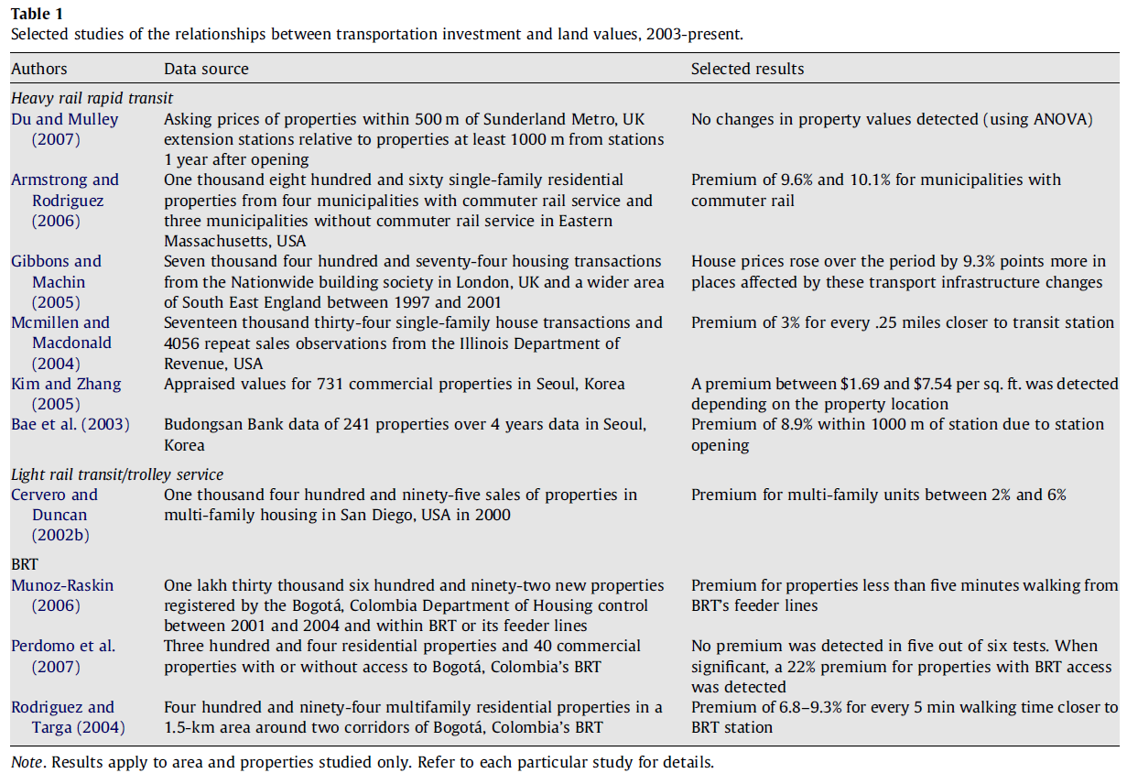
Figure 1. Adapted from Rodriguez and Mojica, 2009
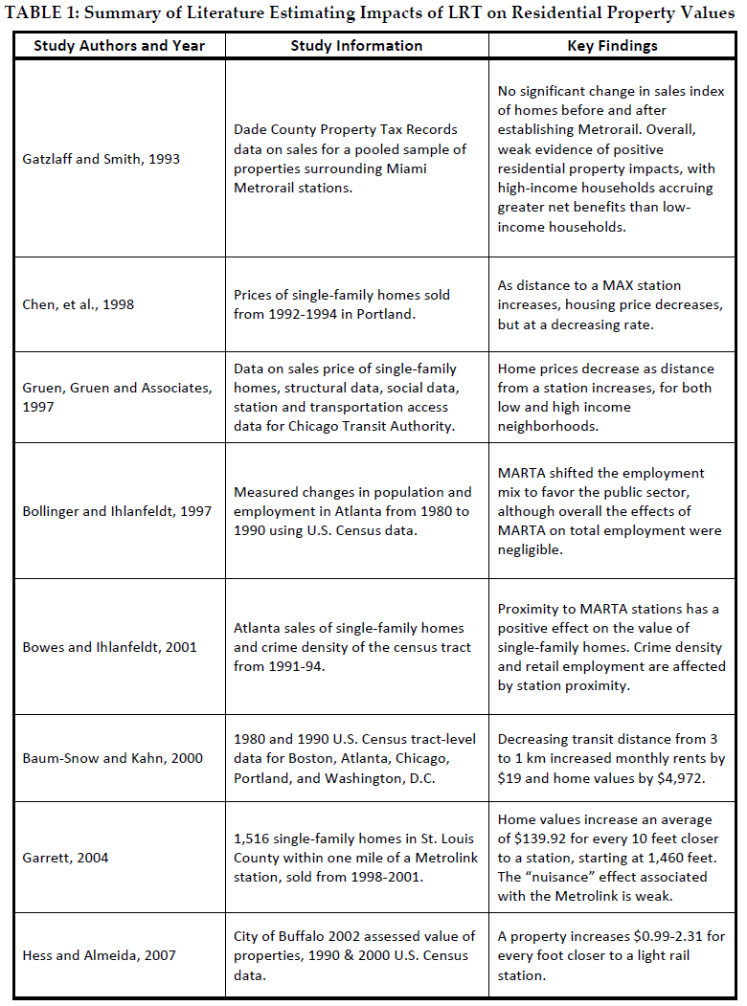
Figure 2. Adapted from Perk and Catala, 2009
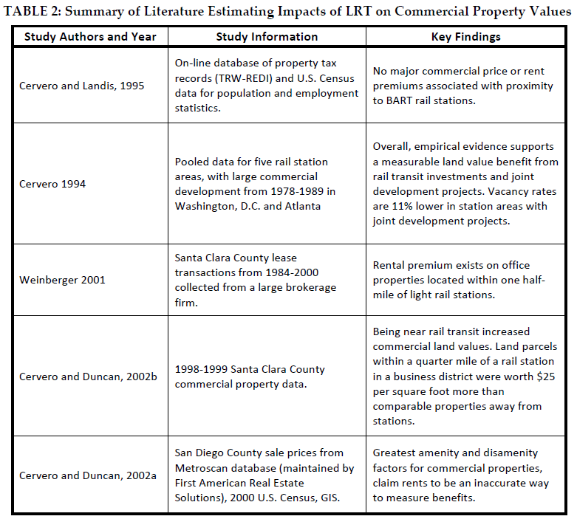
Figure 3 Adapted from Perk and Catala, 2009
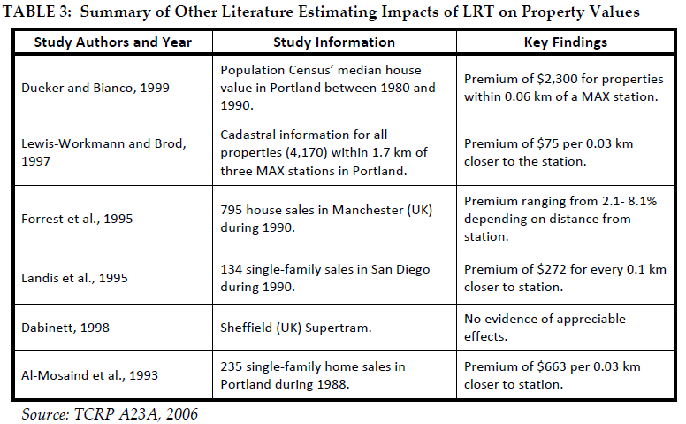
Figure 4 Adapted from Perk and Catala, 2009

References:
Bates, Lisa K. 2013. Gentrification and Displacement Study: Implementing an Equitable, Inclusive Development Strategies in the Context of Gentrification. Report prepared for the City of Portland Bureau of Planning and Sustainability. Retrieved (4/14/15) from: https://www.portlandoregon.gov/bps/article/454027
BRTData.org (2016). BRT Data for the US. http://brtdata.org/location/northern_america/united_states
Chapple, Karen. 2009. Mapping Susceptibility to Gentrification: The Early Warning Toolkit. Report of the Center for Community Innovation, Univ of California – Berkeley.
Cervero, R. B. (2013). Linking urban transport and land use in developing countries. Journal of Transport and Land Use, 6(1), 7–24. ← RR
Cervero, R., & Dai, D. (2014). BRT TOD: Leveraging transit oriented development with bus rapid transit investments. Transport Policy, 36, 127–138. http://doi.org/10.1016/j.tranpol.2014.08.001 ← RR
Cervero, R., & Duncan, M. (2002). Land value impacts of rail transit services in Los Angeles County. Report Prepared for National Association of Realtors Urban Land Institute. Retrieved from https://drcog.org/documents/TODvalueLosangeles.pdf
ECONorthwest. 2015. Gresham Neighborhood Change Analysis. Report to the City of Gresham.
Gauthier, Aimee.2014. “Housing, Transport, and the Fight for Equitable Cities.” Sustainable Transport Winter 2014, no. 25
Higgins, C. D., & Kanaroglou, P. S. (2015). 40 Years of Modelling Rail Transit’s Land Value Uplift in North America: Diverse Methods, Differentiated Outcomes, Debatable Assumptions, and Future Directions. In Transportation Research Board 94th Annual Meeting (No. 15-4103).
Hook, Walter, Stephanie Lotshaw, and Annie Weinstock. 2013. More Development for your Transit Dollar: An Analysis of 21 North American Transit Corridors. Report for the Institute for Transportation and Development Policy. Retrieved (4/14/15) from: https://www.itdp.org/wp-content/uploads/2013/11/More-Development-For-Your-Transit-Dollar_ITDP.pdf
ITDP. (2016a). The BRT Standard. Institute for Transportation and Development Policy, New York. https://www.itdp.org/library/standards-and-guides/the-bus-rapid-transit-standard/
ITDP (2016b). BRT Standard Scores. Institute for Transportation and Development Policy, New York. https://www.itdp.org/wp-content/uploads/2014/11/BRT-2014-Scorecards2.xlsx
Moore, Eli, Samir Gambhir, and Phuong Tseng. Belonging and Community Health in Richmond: An Analysis of Changing Demographics and Housing. Report of the Haas Institute for a Fair and Inclusive Society. Univ of California-Berkeley.
Mulley, C., Ma, L., Clifton, G., Yen, B., & Burke, M. (2016). Residential property value impacts of proximity to transport infrastructure: An investigation of bus rapid transit and heavy rail networks in Brisbane, Australia. Journal of Transport Geography, 54, 41–52. http://doi.org/10.1016/j.jtrangeo.2016.05.010
Nelson, A. C., & Ganning, J. (2015). NATIONAL STUDY OF BRT DEVELOPMENT OUTCOMES. University of Utah: National Institute for Transportation and Communities (NITC). http://t4america.org/wp-content/uploads/2016/01/NATIONAL-STUDY-OF-BRT-DEVELOPMENT-OUTCOMES-11-30-15.pdf
Partnership for Sustainable Communities. 2012. Transit as Transformation: the Euclid Corridor in Cleveland. Retrieved (4/14/15) from: http://ntl.bts.gov/lib/45000/45700/45740/Cleveland-euclid-corridor.pdf
Perk, V. A., & Catalá, M. (2009). Land Use Impacts of Bus Rapid Transit: Effects of BRT Station Proximity on Property Values along the Pittsburgh Martin Luther King, Jr. East Busway. Retrieved from https://trid.trb.org/view.aspx?id=1401767
Pollack, Stephanie, Barry Bluestone, and Chase Billingham. 2010. Maintaining Diversity in America’s Transit-Rich Neighborhoods: Tools for Equitable Neighborhood Change. Report of the Dukakis Center for Urban and Regional Policy, Northeastern University.
Puget Sound Sage. 2012. Transit-Oriented Development that’s Healthy, Green and Just. Report.
Rodríguez, D. A., & Mojica, C. H. (2009). Capitalization of BRT network expansions effects into prices of non-expansion areas. Transportation Research Part A: Policy and Practice, 43(5), 560–571. http://doi.org/10.1016/j.tra.2009.02.003
Thole, C., & Samus, J. (2009). Bus Rapid Transit and Development: Policies and Practices that affect Development around Transit (No. FTA-FL-26-7109.2009. 5).
Wright, L., & Hook, W. (2007). Bus rapid transit planning guide. Institute for Transportation and Development Policy, New York.

