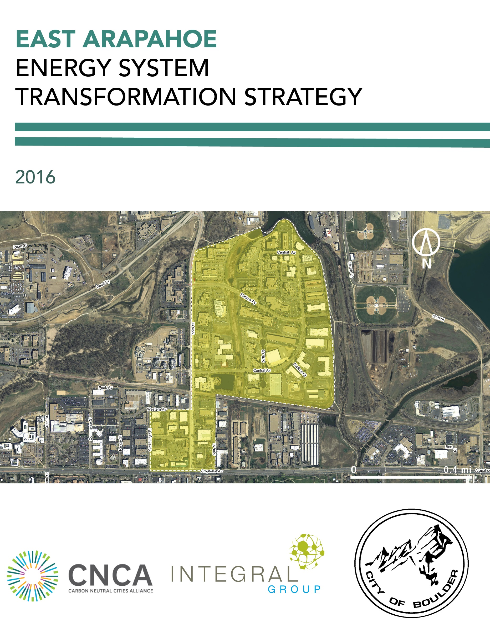

**TABLE OF CONTENTS**

1 Introduction 1

2 A City Positioned for Decarbonization 3

2.1 A Solid Foundation 3

2.2 A Supportive Citizenry 4

2.3 High Level of Control over Energy System Transformation 4

2.4 A Changing Climate 5

3 Neighborhood | East Arapahoe 7

4 Fostering an Energy Sytem Transformation 9

4.1 Baseline Energy and Emissions Scenario 9

Energy Supply 9

Buildings 10

Transportation 10

Summary 11

4.2 Transformation Scenario and High Priority Actions 13

Energy Supply 14

Buildings 16

Transportation 20

Summary 22

# Introduction

Cities across the world are beginning to take climate change seriously, and are implementing a range of strategies, policies and programs to dramatically reduce their greenhouse gas emission contributions into the atmosphere. To avoid a catastrophic level of global warming, these innovative urban centres have pledged to reduce their emissions by 80% by the year 2050, with a longer term target of relying on 100% renewable energy in all aspects of urban life.

To make this transition will require a considerable transformation in the way we work, live and commute, as well as a new way of thinking about and designing our cities. As a starting point, many local jurisdictions are focusing their efforts on the transformation of individual neighborhoods as a way of piloting novel planning tools, development models, and engagement methods. While many of the plans and policies required at the neighborhood scale are applicable to urban systems more broadly, others must be tailored to the unique context and circumstances of a particular area. Existing energy infrastructure, building types, transportation networks, levels of community engagement and many other dimensions need all be considered in weighing the various approaches to decarbonization to ensure the right fit and highest level of success.

With funding from the Carbon Neutral Cities Alliance (CNCA), Integral Group collaborated with the cities of Boulder, Minneapolis, and Seattle in 2016 to develop a step-by-step guide, the Energy System Transformation Playbook (Playbook), to help municipal governments develop an Energy System Transformation Strategy. These strategies are intended to help municipal governments take the steps necessary to foster a transition towards zero emission, resilient, equitable, and decentralized energy systems that can power cities long into the future (as characterized in Figure 1). More information on what comprises a city’s or neighborhood’s energy system and what it will take to foster a transition can be found in the Playbook.



Figure 1 The key dimensions of an energy system transformation, as taken from the Energy System Transformation Playbook. See the Playbook for more information.

To assist in the development of the Playbook, a draft version of the Playbook was applied to a neighborhood in each of the cities involved in the project. The purpose of applying the Playbook to these neighborhoods was to test its content and process, then collaboratively evaluate the application to determine required adjustments for usability and effectiveness. East Arapahoe was used as the test neighborhood in Boulder, and this East Arapahoe Energy System Transformation Strategy is the result. The content of the Strategy, including energy and emissions projections, was developed by Integral Group with input from City staff. **This Strategy is not intended to represent the City’s perspectives on how the neighborhood will develop (e.g. changes in density, development rates).** The recommendations are based on Integral Group’s analysis and the guidance provided in the Playbook. **The team did not conduct stakeholder engagement and the recommended strategies and actions are not intended to represent the perspectives or priorities of the City or other stakeholders.**

**Rather, this Strategy should be viewed as an example analysis of what it will take for a city or neighborhood to eliminate GHG emissions from its energy system (i.e. decarbonize), both in terms of the types of actions and the scale of effort required.** The City of Boulder can use the Strategy and the associated Playbook to inform discussions among City staff and other stakeholders regarding what the City must achieve to transform its energy system to mitigate climate change, among other priorities. The Strategy includes an analysis of and resulting strategies and actions for the three urban systems that comprise a city’s energy system:

* **Energy Supply**, including both grid-supplied and smaller on-site or district scale energy sources;
* **Buildings**, including both new construction and existing buildings, and;
* **Transportation**, including the reduction of fossil fuel-based automotive modes of transportation and the support of alternative means, such as cycling, walking, and public transit.

The Strategy should be used in conjunction with existing plans and policies at both neighborhood and city scales. The contents of the Strategy include:

* A description of the context of Boulder as it is relevant to the process of decarbonization, including any barriers or opportunities;
* A description of the neighborhood of East Arapahoe, including current and projected development profiles;
* A description of the neighborhood’s current energy and emissions profile, including the broad trajectory required to transition to zero carbon; and
* A list and explanation of relevant strategies and actions to be taken over the next 5-10 years.

# A City Positioned for Decarbonization

A number of factors make Boulder an ideal city to begin the shift towards zero carbon. To begin, the City of Boulder’s political environment has historically been supportive of carbon reduction measures, exemplified by Boulder’s early adoption of GHG reduction efforts in 2002 with the Kyoto Resolution. A number of energy and emissions reduction policies have followed – for example, voters passed the nation’s first Climate Action Plan (CAP) Tax in November 2006, and the City is guided by its own climate action plan, *Boulder’s Climate Commitment* (2015). These have been guided and supported by regional and state-level policies and strategies as well, including the vision set out by Boulder County’s *Environmental Sustainability Plan* (2012) and the *Colorado Climate Plan* (2015).

Several of the successes in adopting building efficiency-related policies in Boulder have been realized as a result of its control over municipal building codes. Of these, some important decarbonization initiatives have included the development of:

* *Smart Regs*, which require all rental properties to meet basic energy efficiency standards by 2019;
* *Energy Smart*, which helps homeowners access energy efficiency resources and rebates;
* *Accelerated Net-Zero Energy Code*, which requires new and remodeled residential and commercial buildings to meet net-zero emissions by 2031; and
* *Boulder Building Performance Ordinance*, which requires privately-owned commercial and industrial buildings and city-owned buildings to fulfill a set of criteria related to building energy use rating and reporting, energy assessments, retro-commissioning, and a one-time lighting upgrade

While the city does not yet have control over its source of electricity, current efforts to municipalize their electric utility are helping to improve the ability to shift them even further towards a low or no-carbon energy supply.

## A Solid Foundation

Boulder’s economy is also well-positioned to adopt even greater carbon reduction efforts. With a real GDP growth of 4.6% from 2013-2014, the city’s economy is flourishing. In particular, the presence of clean tech companies that are well-supported by university programs and venture capital funding, as well as the high rates of employment among energy companies in the County, mean that Boulder has a wealth of local knowledge and production experience to expand its renewable energy capacity. Further, Boulder’s electricity prices are consistently lower than both the state and national averages across commercial, industrial, and residential sectors, and are supportive of a shift to a higher use of low and no-carbon electricity. Boulder’s ongoing efforts in the municipalization of the energy utility could provide even greater energy independence and authority over the city’s energy supply.

The city also has a vibrant research economy that includes the University of Colorado Boulder, Federal labs and CO-labs, as well as private sector research organizations. The proximity of the National Renewable Energy Laboratory in Golden, CO presents a key opportunity for the development and careful piloting of new and innovative technologies with strong industry support. Overall, Boulder has the local capacity to market, install, and maintain renewable energy infrastructure, as well as to educate the general public about different ways to incorporate energy efficiency into their lives.

## A Supportive Citizenry

Another important factor in the implementation of both past and future carbon reduction efforts is the tendency of Boulder’s citizenry to support progressive policies. Boulder is characterized by a highly educated population with relatively high incomes and environmentally supportive politics. Boulder is also home to a proportionately large presence of university students, lowering the median age of the population and presenting both potential opportunities and challenges. In general, students have fewer means to invest in capital-intensive renewable energy technologies, and a potentially lower level of personal investment in the built environment given their transient nature and renter-occupancy. However, students are also known for their environmentally progressive tendencies as a demographic, and can form the basis of a labor pool well-suited to the support of complex energy system transformations. That said, a Gini Index of 51.9 indicates a high level of inequality in the city, which must be carefully considered and addressed when designing strategies for decarbonization.

## High Level of Control over Energy System Transformation

The approaches a city selects to undertake an energy system transformation depend partly on the extent of their influence or control over the urban system component in question. Municipal powers over different assets, functions, or decision-making structures vary according to their jurisdiction and circumstances. While one city may have full control over their building code, others may be required to conform to state regulations over building form and energy efficiency.

The CNCA Playbook offers a *sphere of influence mapping* tool to help cities determine their priority energy system transformation strategies based on the level of control or influence they have over each of the key urban system components. The extent of a municipal government’s influence can be determined by placing it into one of three broad categories:

* **Control:** Where a city has near-complete or full decision-making authority over components of the urban system or issue in question.
* **Influence:** Where a city has no decision-making authority, but has access to resources and forums that can be used to influence decision-making by market actors or other levels of government.
* **Interest:** Where a city has neither control nor direct influence over components of the urban system, but is interested in and possibly affected by the outcomes of decisions made by other actors.

Altogether, Boulder has a relatively high level of control over energy supply and buildings relative to other cities, offering the City greater opportunities to foster an energy system transformation more quickly. Figure 2 indicates the City’s level of control over each component of each urban system designated by the cells with orange borders on the Playbook’s the sphere of influence mapping tool. For each urban system component, Boulder can take action on the decarbonization priorities listed in the box designated with orange borders, as well as the cells in the same row to the left of the box. This tool thus provides insight on what the City can and should prioritize to progress the energy system transformation for each urban system component and was used to inform the priority actions presented in this Strategy. Refer to the Playbook for more information on sphere of influence mapping and the decarbonization phases in Figure 2.

## A Changing Climate

Finally, Boulder’s environmental and climatic conditions are also conducive to decarbonization strategies. Boulder’s elevation at 5,430 feet above sea level ensures a mild, high-desert climate, with temperature fluctuations between an average daytime high of 45 degrees in January, and 87 degrees in July. This relatively low temperature variation throughout the year is favorable when switching fuel sources to other forms of thermal energy, such as heat pump technology. The city experiences 245 sunny days during the year, which provides substantial potential for solar energy, and the city already has proven wind energy generation capacity. In terms of projected climate change, Boulder is expected to experience substantial warming by mid-century. Any future increases in air temperatures and frequency of heat waves will consequently increase energy demand for cooling during hotter months. Relatedly, changes in climate patterns could negatively affect wind power through shifts in the spatial distribution and variability of wind speed, and the increased atmospheric water vapor could alter cloud characteristics and therefore impact the efficacy of solar energy generation.

|  |  |  |  |  |  |  |
| --- | --- | --- | --- | --- | --- | --- |
| **Energy System Transformation Phases** | | **Working without Control:** Act where possible + Acquire more control where feasible + Lobby for Implementation of Phases 1-3 | | **Phase 1:** Initiate Energy System Transformation | **Phase 2:** Strategically Decarbonize | **Phase 3:** Zero Emission Energy System |
| **Level of Control** | |  |  |  |  |  |
|  |  |  |  |  |
|  |  |  |  |  |
| **INTEREST** | **INFLUENCE** | **CONTROL** |  |  |
| **ENERGY SUPPLY** | **Grid-Supplied Energy**  **(*Imported*)** | * Increase purchases of clean energy where possible * Conduct outreach campaigns | * Explore/develop MOU with electrical utility to increase clean energy supply | * Procure zero emission energy directly (e.g. power purchase agreements, community choice aggregation)or indirectly (e.g. renewable energy credits) | * Increase zero emission energy supply * Phase out indirect purchases (e.g. renewable energy credits) | City runs on 100% zero emission energy |
| **Neighborhood-Scale Energy**  **(*Local*)** | * Provide programs and incentives * Conduct outreach campaigns * Encourage organizations to procure clean energy * Decarbonize city-owned generators * Increase internal capacity * Purchase clean energy where available | * Use existing powers (e.g. right-of-way) to leverage low emission DES * Use zoning powers to compel low emission DES studies for large developments | * Develop or require development of low emission district energy systems * Require certain new buildings to connect to district energy systems | * Transition from low emission to zero emission DES * Prioritize connection of existing loads to direct energy systems | High intensity loads are served by zero emission district energy as needed |
| **On-Site Energy**  **(*Local*)** | * Provide programs and incentives * Conduct outreach campaigns * Offer bulk buy programs * Increase internal capacity * Install on-site generation at city facilities | * Update regulations to support on-site energy generation | * Evaluate potential for zero emission on-site thermal systems * Develop a renewable energy proliferation strategy * Lobby for authority to allow peer-to-peer energy transactions | * Establish peer-to-peer energy transactions as a key part of the city’s energy market * Implement an on-site renewable energy strategy | Grid-supplied and neighborhood-scale energy supplemented by desired level of on-site generation |
| **Grid Modernization** | * Develop internal capacity to understand grid modernization and its relationship to achieving climate and energy objectives | * Work with utilities to install advanced metering infrastructure | * Require buildings to install advanced meters * Study grid’s ability to host distributed energy resources (with utility) * Lobby state and electric utility to incorporate distributed energy resources into planning | * Develop a location-based profile of energy and emissions * Implement and support pilot projects * Work with state to allow and develop a peer-to-peer energy market | Highly efficient grid capable of supporting desired level of distributed energy resources |
| **BUILDINGS** | **New Buildings** | * Offer incentives * Coordinate bulk buy programs * Support building sector training * Pilot technologies * Study thermal and industrial decarbonization options | * Integrate GHG emissions performance into ‘up-zoning’ and programs | * Develop a roadmap to zero emission building (ZEB) codes * Map trajectory to ZEB performance * Develop Incentive programs with utilities for ZEBs | * Implement ZEB building codes | All new buildings required to be zero emissions |
| **Existing Buildings** | * Provide decarbonization and efficiency programs and incentives * Support building sector training * Pilot technologies * Study thermal and industrial decarbonization options * Implement municipal energy management program * Increase internal capacity | * Explore/develop MOU with utilities to decarbonize buildings | * Offer incentives for decarbonization * Enact a building energy reporting and benchmarking policy * Integrate GHG emissions into retrofit requirements * Develop incentive programs with utilities for ZEBs * Offer decarbonization incentives | * Retrofit all existing buildings to eliminate fossil fuel dependency | All existing buildings retrofitted to operate on zero emission energy |
| **TRANSPORTATION** | **Mode Share** | * Apply transit-oriented development planning * Promote transit, cycling, walking, and tele-working * Support pilot projects and reduce regulatory barriers for new technologies | * Increase attractiveness of non-auto modes * Invest in bicycle sharing * Redevelop neighborhoods into “complete” streets * Redesign goods movement | * Develop non-auto mode infrastructure * Implement road use charges for fossil fuel vehicles | * Expand non-auto mode infrastructure to increase coverage and demand | Multi-model transportation network offers people multiple zero emission options |
| **Zero Emission Vehicles and Fuels** | * Coordinate bulk buy programs * Convert fleets to low- and zero-emission vehicles * Encourage adoption of low- and zero-emission vehicles (ZEVs) | * Develop partnerships for ZEV car share * Develop partnerships for electric vehicle infrastructure * Support shift from trucks to rail * Lobby state government to mandate ZEV sales | * Install electric vehicle (EV) charging infrastructure in high priority locations * Require EV charging infrastructure capabilities in buildings and parking lots * Incentivize ZEV ownership | * Require vehicle charging stations in buildings and parking lots * Adjust ZEV incentives based on costs and market adoption * Disincentivized fossil fuel vehicle ownership | All vehicles run on zero emission fuels |

*Figure 2 Boulder’s level of control for each urban system component according to the Playbook’s sphere of influence mapping tool.*

# Neighborhood | East Arapahoe

The focus of the City of Boulder’s preliminary efforts in transforming the city towards zero carbon is the neighborhood of East Arapahoe, located north of Arapahoe Avenue, and bordered by 55th Street to the west and by South Boulder Creek to the east (Figure 1). Under the transect framework, the neighborhood can be qualified as a “Special District”, in that it does not conform to the characteristics outlined in any of the Transect Zones. This neighborhood is almost exclusively a light industrial area, with commercial and office building functions mixed in. As such, the East Arapahoe area has a very low density, characterized by large building lots and expansive building footprints. Building heights are generally limited to 1- to 2-stories, with a few 3- to 5-story structures interspersed throughout. Wide roadways connect individual lots and are lined by extensive on- and off-street parking. While sidewalks are present throughout the area, the pedestrian experience itself is limited by the relative lack of vegetation and points of interest, compounded by the large distance between building frontages. East Arapahoe’s current condition is therefore characterized by a primarily car-oriented design and the prevalence of private ownership of land, with an absence of civic uses of facilities.

Interestingly, recent investment in the area has introduced new types of businesses. For example, microbreweries Wild Woods Brewery and Upslope Brewing have taken advantage of the permitted usage of the industrial park, providing a much needed dynamism to East Arapahoe. Other notable magnets include Blackbelly Market, which has expanded from an upscale restaurant and bar to include a butcher shop, as well as OZO Coffee Roasters and their Coffee Lab and Training Center. These types of services are also being complemented by new and innovative companies such as software company Tap Influence, and outdoor gear manufacturer Sea to Summit.

While the East Arapahoe area is currently dominated by industrial and manufacturing enterprises, it is slated for redevelopment, with a number of future scenarios under consideration. Depending on the scenario the City ultimately chooses to pursue, redevelopment will have a range of potential impacts on both energy demand and the quantity of GHG emissions produced by the neighborhood. However, all scenarios include a significant level of redevelopment (>50%), and as such will need to incorporate aggressive standards for both new and existing buildings.

Currently, a small number of organizations own a lot of land and buildings in the neighborhood. This may provide an opportunity to install a large amount of on-site and neighborhood-scale renewable energy systems with minimal transaction costs. One of these organization is already exploring the potential to install an array of solar panels. Interestingly, several renewable energy manufacturing industries are located within East Arapahoe: Gridcure (smart grid data analytics), PV Measurements (instrumentation for photovoltaics), Cool Energy (heat-to-electricity engines), and Wind Tower Technologies (wind energy engineering consulting). The concentrated land ownership, existing interest in solar panels, and presence of cleantech companies within the neighborhood may offer not only a potential avenue for local economic development, but also for local capacity building and stakeholder engagement.

However, the neighborhood also faces some challenges. Among the greatest potential barriers to East Arapahoe’s decarbonization efforts is the absence of public transit service within the neighborhood. This is being addressed by the proposed *East Arapahoe Transportation Plan*, which attempts to reconcile the current land use pattern and the feasibility of future transit options within the corridor. The City of Boulder has partial control over the transportation network, given its authority over pedestrian and cycling infrastructure, but has a lesser role with respect to public transit, as it is subject to collaboration with the Regional Transportation District (RTD). While there is a bicycle lane on Arapahoe Avenue that provides active transit access to downtown Boulder, East Arapahoe will need to a provide a wide range of transportation options, including public transit service and electric vehicle charging infrastructure, if the area is to be developed as a decarbonized community.

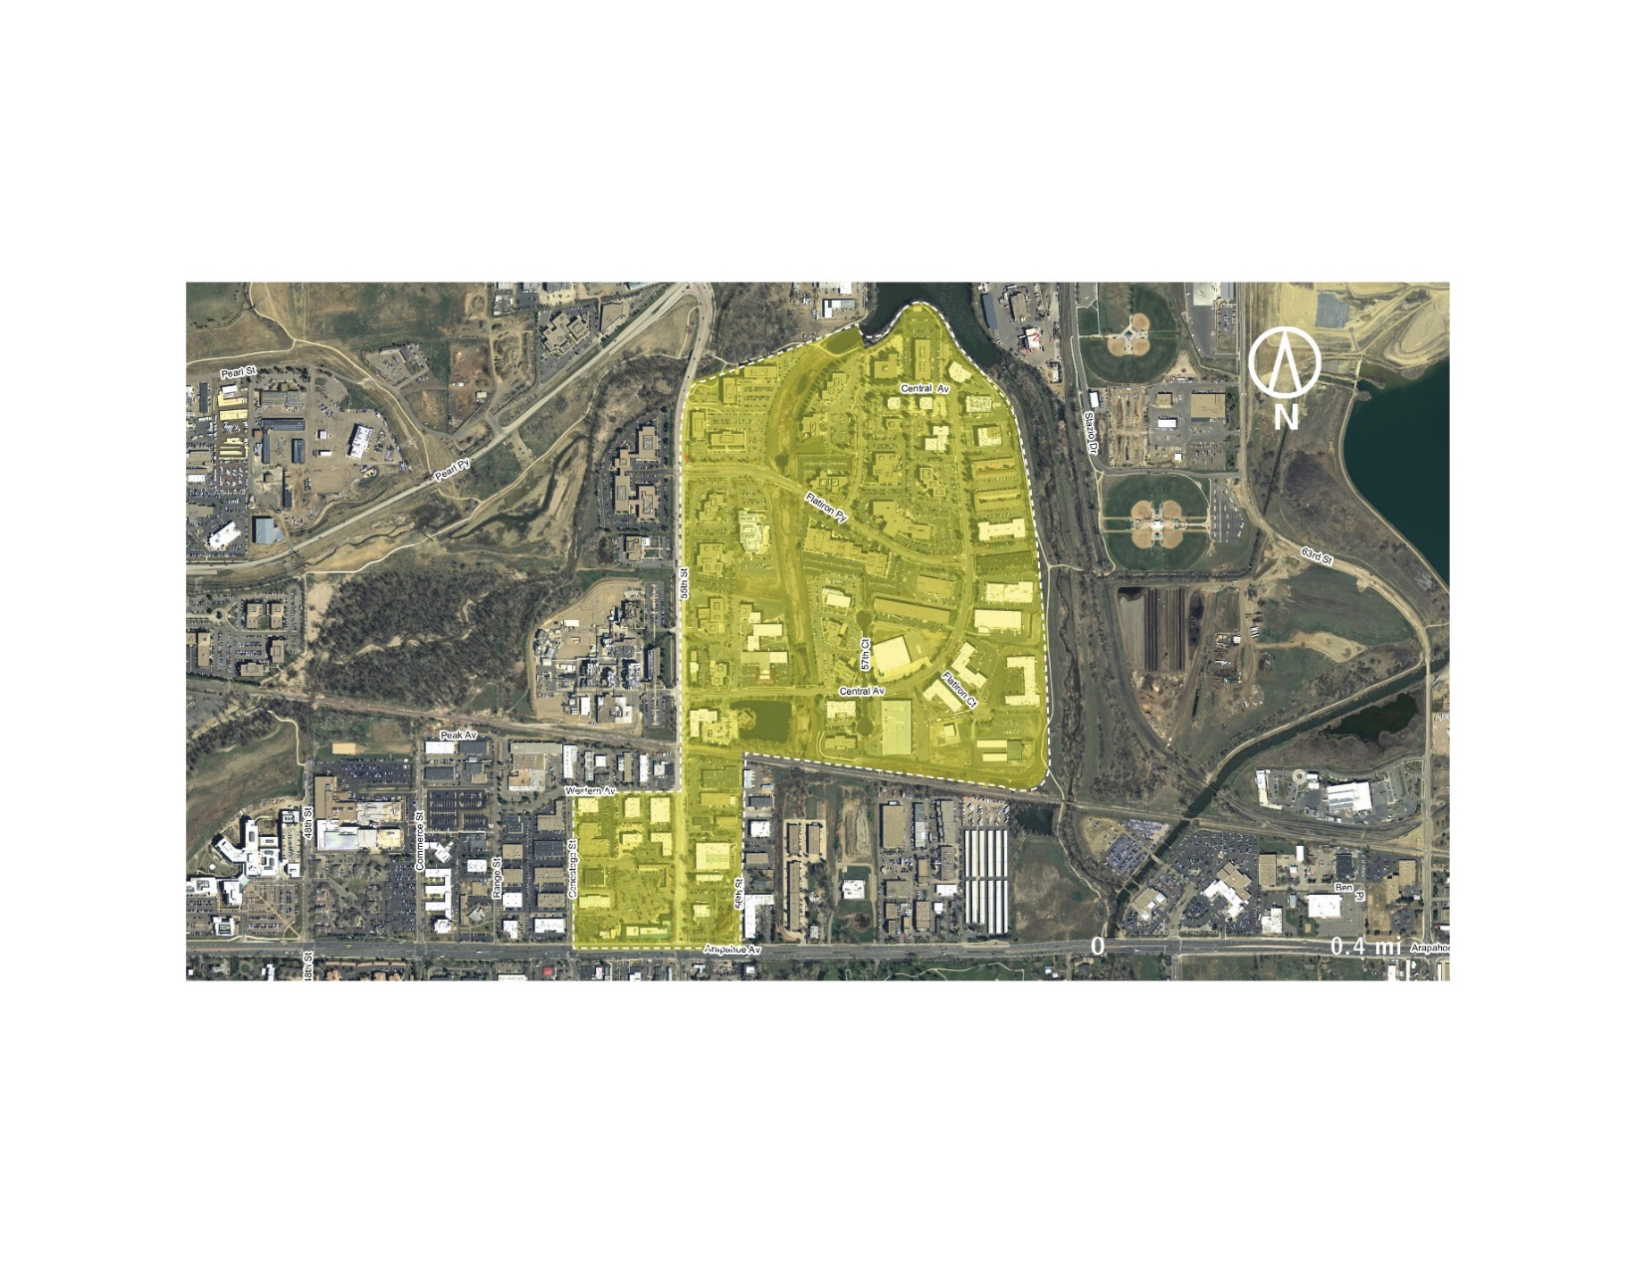

*Figure 3 The boundary of Boulder’s East Arapahoe neighborhood used in the development of this Strategy*

# Fostering an Energy Sytem Transformation

The remainder of this Strategy presents two energy and emissions scenarios: a *Baseline Scenario* assuming business-as-usual activities, and a *Transformation Scenario* developed to eliminate GHG emissions from the neighborhood. We used the *Transformation Scenario* alongside the CNCA Playbook to identify the City’s top priorities in each urban system—energy supply, buildings, and transportation—to decarbonize the neighborhood. We discuss these priorities alongside strategies and actions drawn from the Playbook. Energy consumption and GHG emissions are quantified for both scenarios.

Recall that this Strategy is intended to help inform discussions between City staff and other stakeholders regarding what the City must achieve to transform its energy system to mitigate climate change, among other priorities. This Strategy does not present a specific plan to achieve decarbonization, but rather identifies top priorities and the strategies and actions the City can use to achieve them. Readers should view the *Transformation Scenario* and associated priority strategies and actions in this light.

## Baseline Energy and Emissions Scenario

To understand what East Arapahoe could be, it is important to first understand what it is, including the energy use and emissions associated with current development projections for the area. Under the scenario modeled for this analysis, development in the East Arapahoe neighborhood is expected to approximately double in size, adding 2.2 million square feet. Almost entirely a commercial and industrial area in its current state, this new growth will be evenly split between multifamily residential development and commercial, industrial, and institutional development (both approximately 1.1 million square feet). The changing composition of the neighborhood towards increased residential uses will see natural gas playing a larger role in the neighborhood’s GHG emissions, while increased jobs and new housing in the area will drive increases in transportation demand and associated gasoline and diesel consumption. The neighborhood’s total energy consumption and GHG emissions are presented in Table 1.

In addition to new development, the neighborhood’s energy and emissions will be affected by existing policies and programs, as well as assumptions about the future electricity mix and transportation demand. The policies, programs, and assumptions included in the *Baseline Scenario* are listed by energy system below:

### Energy Supply

* Current and future electricity GHG intensity is based on the *Xcel Average Scenario* as modeled in Boulder’s Climate Commitment Tool. Under this scenario, electricity will be approximately 35% less GHG intensive in 2050 than it is today. This scenario is projected to satisfy both the Colorado Renewable Portfolio Standard and the federal Clean Power Plan.

*Table 1 Summary of current and future energy consumption and GHG emissions.*

|  |  |  |  |  |  |
| --- | --- | --- | --- | --- | --- |
| GHG Emissions (tCO2e) | Current | 2020 | 2030 | 2050 | % Change from Current by 2050 |
| Total* | 46,900 | 42,300 | 41,000 | 41,000 | -13% |
| by sector |  |  |  |  |  |
| Buildings | 23,600 (50%) | 22,100 (52%) | 24,200 (59%) | 18,800 (46%) | -20% |
| Transportation** | 23,300 (50%) | 20,200 (48%) | 16,800 (41%) | 22,200 (54%) | -5% |
| by fuel type |  |  |  |  |  |
| Electricity | 18,900 (40%) | 17,300 (41%) | 18,600 (45%) | 15,800 (39%) | -16% |
| Natural Gas | 4,700 (10%) | 4,900 (12%) | 6,300 (15%) | 6,400 (16%) | +36% |
| Gasoline and Diesel | 23,300 (50%) | 20,100 (48%) | 16,100 (39%) | 18,800 (46%) | -19% |

|  |  |  |  |  |  |
| --- | --- | --- | --- | --- | --- |
| Energy Consumption (MMBtu) | Current | 2020 | 2030 | 2050 | % Change from Current by 2050 |
| Total* | 503,800 | 466,300 | 461,300 | 526,900 | +5% |
| by sector |  |  |  |  |  |
| Buildings | 189,100 (38%) | 192,900 (41%) | 236,000 (51%) | 234,500 (45%) | +24% |
| Transportation** | 314,700 (62%) | 273,300 (59%) | 225,200 (49%) | 292,400 (55%) | -7% |
| by fuel type |  |  |  |  |  |
| Electricity | 100,000 (20%) | 101,400 (22%) | 119,500 (26%) | 126,500 (24%) | +27% |
| Natural Gas | 89,100 (18%) | 92,000 (20%) | 118,400 (26%) | 120,300 (23%) | +35% |
| Gasoline and Diesel | 314,700 (62%) | 272,900 (58%) | 223,400 (48%) | 280,100 (53%) | -11% |

*Numbers may not sum due to rounding.   
**Heavy and medium duty vehicles other than transit vehicles are not captured here due to incomplete information at the time of writing.

### Buildings

* The model assumes both the *EnergySmart Commercial Program,* which targets energy use reductions in existing buildings (modeled until 2018[1]), and the *Commercial and Industrial Building Performance Ordinance,* which targets energy use reductions in existing buildings (modeled until 2050).
* Building codes are assumed to continue to be 30% more energy efficient than the International Energy Conservation Codes (i.e. become more stringent until 2030, then remain static until 2050).
* Stringencies and application periods for existing building programs and new building codes were informed by Boulder’s Climate Commitment Tool.

### Transportation

* Passenger vehicle fuel efficiencies are assumed to steadily improve until 2025 as a result of the federal Corporate Average Fuel Economy (CAFE) Standard, then remain static.
* Electric vehicle (EV) adoption increases are based on assumptions about the EVs’ share of new vehicle sales in each year. This is currently approximately 1.8%[2] and is assumed to grow modestly to 5% by 2030, 10% by 2040, and 20% by 2050.
* Transportation demand (vehicle miles traveled, VMT) is assumed to grow alongside growth in the building stock, while mode share is assumed to stay approximately constant at 90% passenger vehicle, 6% transit, and 4% cycling and walking.
* Current and future transportation demand and mode shares were provided by the City of Boulder, and calculated based on the building types and associated job and housing numbers, data from Boulder’s transportation survey, and guidance on calculating trip generation from the Institute for Transportation Engineer’s Trip Generation Manual.

In sum, while growth in the building stock and associated transportation demand drives increases in energy consumption and emissions, the policies, programs, and assumptions listed above will have a downward or neutral effect on energy and emissions. The cumulative effect of these pressures on energy and emissions is summarized in Table 1 above.

### Summary

The impact of the programs, policies, and assumptions on emissions from each sector is summarized in the wedge diagram in Figure 4, where each colored wedge represents GHG emissions that are avoided. The total emissions *without* these programs, policies, and assumptions are approximately 55% higher in 2050 than in 2016 (represented by the top of the wedge diagram). The grey area at the bottom of the diagram represents those emissions that will remain *after* all existing programs, policies, and assumptions have been applied, which are approximately 13% lower in 2050 than in 2016. The majority of reduction that are achieved in this scenario are attributable to the federal CAFE Standard (58%); the remaining 42% is split between those emissions that are avoided through increasingly stringent building codes (27%), and those emissions reduced through existing building energy efficiency programs (13%). Electric vehicle adoption has a negligible impact on emissions due to assumptions around low adoption.

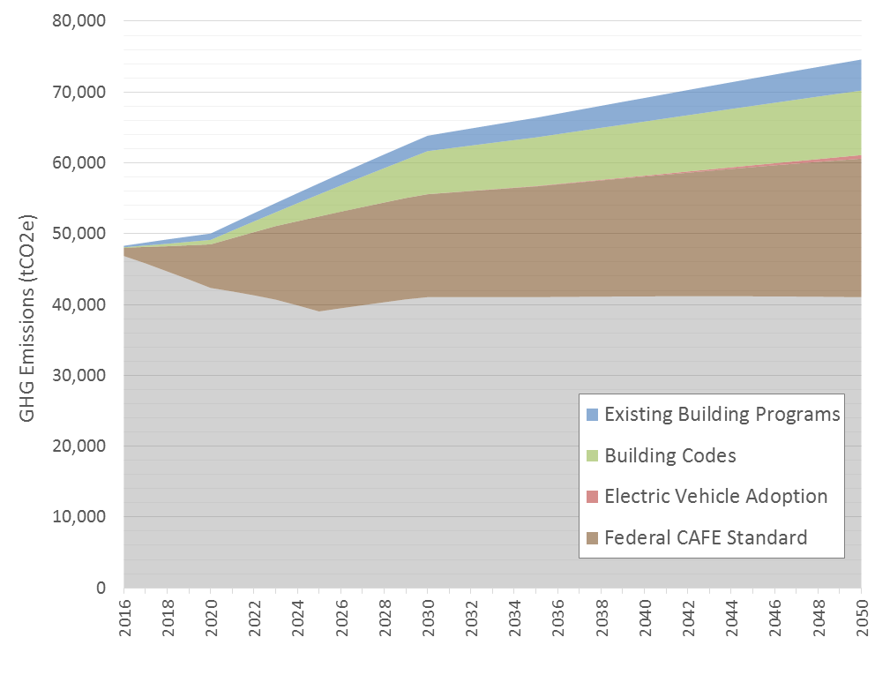

Figure 4 Baseline Scenario GHG emissions projection for East Arapahoe, with wedges representing emissions avoided or reduced.

## Transformation Scenario and High Priority Actions

Based on the assumptions modeled above, business-as-usual policies, programs, and technology adoption are projected to lead to lower GHG emissions by 2050 despite growth in energy demand from new development and increased travel. However, new action is required to place East Arapahoe on a path to zero emissions. To better understand what actions are required, a set of new policies, programs, and assumptions were modeled to decarbonize electricity supply, eliminate fossil fuel dependency in buildings and vehicles, and improve energy efficiency. The projected energy and emissions of this *Transformation Scenario* are summarized in Table 2. The remainder of the section identifies priority focus areas for each urban system, discusses the *Transformation Scenario*, and lists relevant strategies and actions from the Playbook that can help the City decarbonize the neighborhood.

Table 2 Summary of current and future energy consumption and GHG emissions.

|  |  |  |  |  |  |
| --- | --- | --- | --- | --- | --- |
| GHG Emissions (tCO2e)* | Current | 2020 | 2030 | 2050 | % Change from Current by 2050 |
| Total* | 46,900 | 32,800 | 26,000 | 7,800 | -83% |
| by sector |  |  |  |  |  |
| Buildings | 23,600 (50%) | 14,600 (45%) | 13,500 (52%) | 0 (0%) | -100% |
| Transportation** | 23,300 (50%) | 18,200 (55%) | 12,500 (48%) | 7,800 (100%) | -67% |
| by fuel type |  |  |  |  |  |
| Electricity | 18,900 (40%) | 10,600 (32%) | 10,700 (41%) | 0 (0%) | -100% |
| Natural Gas | 4,700 (10%) | 4,100 (13%) | 3,400 (13%) | 0 (0%) | -100% |
| Gasoline and Diesel | 23,300 (50%) | 18,100 (55%) | 11,900 (48%) | 7,800 (100%) | -67% |

|  |  |  |  |  |  |
| --- | --- | --- | --- | --- | --- |
| Energy Consumption (MMBtu) | Current | 2020 | 2030 | 2050 | % Change from Current by 2050 |
| Total* | 503,800 | 431,400 | 366,800 | 296,000 | -41% |
| by sector |  |  |  |  |  |
| Buildings | 189,100 (38%) | 185,200 (43%) | 197,500 (54%) | 154,200 (52%) | -18% |
| Transportation** | 314,700 (62%) | 246,200 (57%) | 169,300 (46%) | 141,700 (48%) | -55% |
| by fuel type |  |  |  |  |  |
| Electricity*** | 100,000 (20%) | 108,200 (25%) | 137,400 (37%) | 190,900 (64%) | +91% |
| Natural Gas | 89,100 (18%) | 77,900 (18%) | 64,800 (18%) | 0 (0%) | -100% |
| Gasoline and Diesel | 314,700 (62%) | 245,300 (57%) | 164,700 (45%) | 105,100 (36%) | -67% |

*Numbers may not sum due to rounding.   
**Heavy and medium duty vehicles other than transit vehicles are not captured here due to incomplete information at the time of writing.  
***Part of the increase in electricity consumption is due to fuel switching away from natural gas to electricity in buildings. A one-to-one conversion rate is applied, meaning 1 kBtu of natural gas becomes 1 kBtu of electricity after the fuel switch. The one-to-one conversion rate does not account for the fact that electrical appliances and systems (e.g. for cooking, heating) are more efficient than those using natural gas. In actuality, 1 kBtu of natural gas would convert to somewhere between 0.5 and 0.25 kBtu of electricity, depending on the appliance or building system and climate zone, among other things. However, not enough data about energy use and fuel mix was available to calculate the proper conversion rate. Therefore, a one-to-one ratio is used and can be considered a conservative assumption that causes electricity use to be overestimated.

### Energy Supply

|  |
| --- |
| Priority Focus to Achieve Decarbonization |
| * Continue pushing for municipalization and zero emission electricity * Supplement grid electricity with local solar to generate other benefits (e.g. resilience, local economic development, energy independence), to increase support for energy system transformation, and to speed up GHG reductions |

To decarbonize East Arapahoe, the City of Boulder must eliminate GHG emissions from its grid-supplied electricity. The *Transformation Scenario* uses the Boulder Climate Commitment Tool’s *Muni Scenario (Low Cost, meets 100% by 2050)*, which assumes the steady elimination of fossil fuels from the supply by 2050.

Grid electricity can also be supplemented by on-site and neighborhood-scale solar systems, but these systems cannot meet 100% of projected electricity needs. Projected electricity consumption and the portion that can be met by on-site solar panels are summarized in Table 3. The estimated solar capacity that could be installed in East Arapahoe is approximately 9.9 MW.[3] The table denotes what portion of total electricity consumption could be met by these panels under two assumptions about capacity factors: assuming the current capacity factor (13.5%) remains, and assuming solar panel, storage, and grid management technologies improve and can be integrated to realize a much higher capacity factor (30%). In both cases, the results indicate that the neighborhood will continue to depend on the grid for a portion of its electricity.

*Table 3 Projected electricity consumption and required solar capacity to meet 100% of demand.*

|  |  |  |  |  |
| --- | --- | --- | --- | --- |
|  | Current | 2020 | 2030 | 2050 |
| Electricity consumption (MWh) | 29,300 | 31,900 | 41,500 | 59,500 |
| Potential solar capacity (MW) | 9.9 | | | |
| % consumption that can be met with potential solar capacity |  |  |  |  |
| assuming 13.5% capacity factor | 40% | 37% | 29% | 21% |
| assuming 30% capacity factor* | 89% | 82% | 63% | 44% |

*The 30% capacity factor is used for illustrative purposes only. It assumes improvements in solar panels and integration of solar, storage, and grid management technologies increase the capacity factor that can be realized.

In deciding on how to satisfy the neighborhood’s electricity demand, the City will need to consider the trade-offs of two major options: 1) using 100% decarbonized grid electricity, or 2) supplementing grid electricity with on-site solar. Where opting to increase local distributed energy generation, the City will need to consider impacts on the electricity grid and undertake grid modernization actions to accommodate the distributed energy resources (these are not discussed in this Strategy). Some of the strengths, weaknesses, opportunities, and threats associated with each of these two pathways are summarized in Table 4.

*Table 4 Example trade-offs in choosing grid electricity versus on-site solar based on a simple SWOT analysis.*

|  |  |  |
| --- | --- | --- |
|  | Decarbonized grid electricity | On-site solar |
| Strengths | * Necessary to satisfy overall demand * Critical to eliminating GHG emissions in Boulder * Requires less investment in and management of local grid infrastructure * Lower impact on rates (likely) * More efficient (fewer resources per GHG reduced) | * Can support faster GHG reductions for East Arapahoe |
| Weaknesses | * No local economic benefit * No impact on public motivation to support climate and energy actions * Will take many years to achieve | * Cannot satisfy full demand * Potential impact on higher rates * More resource intensive, potentially reducing public and private resource available for other climate and energy action (more resources per GHG reduced) |
| Opportunities | * Reduces GHGs from all electricity used in Boulder | * Can generate local economic benefits * Can be used to grow citizen and business support for climate and energy actions * Can increase citizen and business interest in energy efficiency |
| Threats | * City has less control over outcome (at this point) | * May be stalled or inhibited by increased number and complexity of projects and transactions |

The City of Boulder must decarbonize its grid to achieve an energy system transformation. Continued efforts to municipalize the electric utility and shift to zero emissions sources should be paramount.

|  |
| --- |
| Example: California Solar Ordinances |
| Two cities in California, Lancaster and Sebastopol, require new homes to install solar panels. Sebastopol’s ordinance is unique in that it requires solar on both residential and commercial buildings and targets new construction, major additions, and retrofits. Where solar power is impractical or not feasible, buildings may use other forms of renewable energy, or elect to pay a fee. |

The City does not need to install local renewable energy generation to decarbonize, but doing so can yield other benefits that may be priorities for the City or other stakeholders (e.g. resilience, energy independence, local economic development). Installing local renewable energy generators (e.g. solar panels) may also increase support for the overall energy system transformation. Therefore, the City can investigate the value of working to increase solar panels in the neighborhood, but ensure that dedicating resources to this endeavour supports overall city decarbonization, including not removing limited resources focused on decarbonizing the electricity grid. Where focusing on increasing on-site renewable energy generation, the City should prioritize the following strategies and related actions from the Playbook:

**E.14 – Mandate renewable energy generation in buildings**

E.14.1. Require new buildings and major renovations to be capable of supporting a minimum amount of on-site renewable energy generation (e.g. roof design, electrical system capabilities)

E.14.2. Require new buildings and major renovations to generate a minimum amount of renewable energy on-site, with exceptions (e.g. shading on rooftops)

**E.7 – Implement a Renewable Electricity Proliferation Strategy**

E.7.1. Invest in a city-run program to increase renewable energy generation by strategically targeting buildings, neighbourhoods, businesses, and homeowners based on generation opportunities (e.g. rooftop suitability, electricity distribution capacity)

Box 1 lists other actions the City could consider to support its energy supply priorities. As noted above, the City will also need to modernize its grid if adding significant amounts of renewable energy generation (e.g. solar panels) to the neighborhood. The Playbook provides strategies and actions the City can consider to support grid modernization. Action numbers (e.g. E.2.1) correspond to the strategies and actions table found in the Appendix of the Playbook.

|  |
| --- |
| Box 1 Other Relevant Energy Supply Actions from the Playbook |
| E.2.1. Implement a media, outreach, and communications strategy focused on increasing public awareness of efforts and specific programs and increasing adoption of programs  E.4.1. Provide financial incentives for on-site and off-site renewable generation (e.g. property tax breaks)  E.9.4. Invest in “community solar” projects  E.11.2. Provide a centralized online clean energy and energy efficiency commerce system that provides information on programs, access to financing and permits, and connection to support staff |

### Buildings

|  |
| --- |
| Priority Focus to Achieve Decarbonization |
| * Implement zero emission building codes that eliminate building dependence on fossil fuels * Develop an innovative fuel switch retrofit program that eliminates fossil fuel dependency from all existing buildings * Investigate building thermal and industrial energy needs and decarbonization options |

To successfully achieve an energy system transformation, the City needs to eliminate GHG emissions from all new and existing buildings. This will require both new building codes and an unprecedented retrofit program that eliminates fossil fuels from all buildings while making them much more efficient. In many cases, eliminating fossil fuel dependency can be achieved by converting building systems and switching technologies so buildings are powered entirely by electricity. However, this will not be possible for all buildings. In particular, Boulder (alongside other cities) will need to investigate how best to decarbonize building thermal systems (which often rely on natural gas) and industrial buildings (which can have unique and specific energy needs).

|  |
| --- |
| Example: Retrofit Programs |
| Energiesprong is a program with its roots in the Netherlands that aggregates demand to deliver net-zero energy retrofit packages to existing social housing. The program organizes homeowners, contractors, and housing associations to provide a fully integrated platform – renovations can be completed in under a week and homeowners pay a monthly fee similar to their previous energy utility bill – all while eliminating home-sourced emissions, providing a return on investment, as well as a long term (30+ years) energy performance guarantee.  The New York City retrofit accelerator is another exemplar program that offers independent, customized technical assistant and advisory services at no charge to building owners to help facilitate the process of energy and water efficiency upgrades. |

The *Transformation Scenario* assumes that the City of Boulder will follow a path to Net Zero Energy building codes by 2030.[4] Significantly more energy efficient building codes are required to prevent further significant increases in energy demand and built-in fossil fuel dependency. In addition to codes, the City will be required to implement a proactive retrofit strategy that retrofits all existing buildings to eliminate any fossil fuel dependency (i.e. fuel switching retrofits), and make buildings more energy efficient (i.e. energy efficiency retrofits). This retrofit strategy is different than the City’s planned policy to require all major retrofits to be net zero by 2031; rather than simply require retrofits to be net zero, this strategy also requires the City to get building owners who were not considering retrofits to conduct them.

|  |
| --- |
| Example: Zero Emissions Building Code |
| Brussels provides an example of a successful regulatory process that has shifted the Capital Region from among the lowest building insulation standards in the early 2000s, to one of the most stringent building energy codes in Europe today. The affordability and feasibility of Passive House standards were first demonstrated through the Exemplary Buildings pilot program (2007-2009), eventually leading to the adoption of the Passive House ordinance in 2009, which mandated all new public construction to follow Passive House standards by 2010, and all new construction and all retrofits to follow as of January 2015. This commitment by the local government was supported by the broader Energy Performance and Indoor Environment in Buildings Regulation, which adopted the targets of the European Energy Performance of Buildings Directive, requesting all buildings to be Nearly-Zero Energy Buildings by the end of 2020.  Dún Laoghaire-Rathdown, a county in the Dublin Region of Ireland, recently adopted its county development plan for 2016-2022, including an ordinance that requires all new buildings to be constructed to the Passive House standard. This standard restricts space heating and cooling energy demands, provides air tightness and thermal comfort requirements, and limits the primary energy demand of the entire building. These standards are achieved through a variety of building efficiency strategies, including: thermal insulation, passive house windows, ventilation heat recovery, airtightness of the building, absence of thermal bridges, as well as other innovative approaches, such as the solar orientation of the building, or the use of deciduous trees to provide shade in the summer and allow sunlight in the winter. |

The *Transformation Scenario* assumes 100% of natural gas will be eliminated from buildings through retrofit programs that affect approximately 3% of the building stock annually between 2017 and 2050. As noted above, for most buildings this can be accomplished via a shift to electricity; for others, such as industrial facilities, it will require the use of alternative low-emission fuels. It should be noted that this scenario also assumes that all natural gas use is shifted to electricity at a one-to-one rate. As noted under Table 2, the result of this assumption is the likely overestimation of projected electricity consumption, as electricity-powered building systems are generally more efficient than natural gas-powered systems,[5] while some natural gas may be replaced by alternative fuels. Finally, this scenario assumes the City implements an energy efficiency retrofit program that reduces building EUIs by 30% to 50% in 2.5% of the building stock annually between 2017 and 2050.

Key challenges in eliminating GHG emissions from the built stock will include:

* The need to understand and identify explore opportunities to reduce energy use and emissions from both new and existing industrial buildings;
* The achievement of the drop in EUIs as proposed under NZE code for new construction, and;
* The achievement of aggressive retrofit rates in existing buildings that target both energy efficiency and fossil fuel dependency, as well as the need to run an effective fuel switching retrofit program.

The City of Boulder has already been active in establishing a number of building ordinances and new building code requirements that are shifting the city towards decarbonization. However, strategies for both new construction and existing buildings that push the city further towards a zero emission built environment can build upon these efforts. In East Arapahoe, the high proportion of industrial buildings also indicates the need for industry-specific measures and partnerships that can help transition this sector towards zero carbon, including energy management programs. However, these have not been identified in the CNCA Playbook. Priority strategies and actions from the Playbook therefore include the following:

**B.13 – Mandate no- to low-carbon standards for new construction**

B.13.1. Adopt/phase-in building and energy conservation and GHG emissions-based codes based on carbon neutral, zero net energy, Passivhaus, Living Buildings, and other cost-effective high-efficiency approaches

**B.14 – Mandate performance improvement of existing buildings**

B.14.2. Require “deep” retrofitting of buildings at designated in­tervention points: time of sale/purchase, permitting, financing, major renovation of building or space, rebuilding, and tenant turnover.

It must be reiterated that while the City has already begun to develop a path to a Net-Zero Energy building codes by 2030 and has programs focused on existing building retrofits, it is important that both codes and retrofits be designed to specifically shift away from fossil fuels if the City wishes to decarbonize.

Box 2 lists other actions the City could consider to support its building priorities. Action numbers (e.g. B.1.2) correspond to the strategies and actions table found in the Appendix of the Playbook.

|  |
| --- |
| Box 2 Other Relevant Building Actions from the Playbook |
| B.1.2. Promote building energy rating systems (commercial and residential)  B.1.4. Promote voluntary “stretch” building energy conservation codes and green-building principles by providing information and technical assistance  B.1.5. Promote “cool roofs”, air tightness testing, and other low-cost energy conservation approaches  B.1.6. Support best practice information sharing among building owners  B.2.3. Promote green leasing for commercial buildings that enable a fair proportion of costs/benefits to be allocated to both tenants and landlords  B.2.4. Provide energy management resources to support organizations in managing energy and emissions (e.g. shared energy managers)  B.4.1. Offer financial incentives to increase adoption of specific, strategically important technologies (e.g. to enable decarbonization)  B.5.1. Improve access to specialized financing to pay for ef¬ficiency improvements (e.g. green bank, PACE financing, carbon tax with distribution fund)  B.6.2. Promote supportive market mechanisms such as building appraisal and mortgage underwriting that capture the value of investments in energy efficiency  B.7.1. Support efforts to train building operators in energy efficiency best practices  B.7.2. Invest in the sustainable buildings sector to improve the capacity of local or regional industry members to market, install, and maintain the technologies necessary for decarbonization  B.8.2. Pilot new building technologies on city buildings  B.10.1. Implement Municipal Strategic Energy Management programs to decrease energy consumption and GHG emissions in municipal government buildings  B.10.2. Conduct deep retrofitting combined with installation of on-site renewable energy supply  B.10.3. Improve building operations and preventative maintenance  B.12.3. Require sub-metering  B.13.3. Implement a program or office to increase code compliance  B.14.4. Require higher standards for energy efficiency of appliances  B.14.5. Require energy performance check-ins and/or improvement actions (e.g. audit, recommissioning) at designated time intervals (e.g. every 5 years) |

### Transportation

|  |
| --- |
| Priority Focus to Achieve Decarbonization |
| * Use land use planning and urban design powers to ensure neighborhoods and developments support transit, biking, and walking * Mandate electric vehicle readiness in buildings and parking lots * Lobby the state government to adopt California’s zero emission vehicle mandate |

Decarbonizing East Arapahoe (and the rest of the city) requires Boulder to eliminate its dependency on gasoline and other petroleum fuels for transportation. One way this can be achieved is through a steady shift in mode share towards greater transit, cycling, and walking. The *Transformation Scenario* assumes the City achieves the 2035 and 2050 mode share targets outlined in the *Boulder Transportation Master Plan*:

* 10% transit and 30% walking and biking by 2035, and;
* 14% transit, and 38% walking and biking by 2050.

Under this scenario, some gasoline and diesel use still remains for three reasons:

* The model uses a simple algorithm that assumes only 4% of the vehicle stock is replaced with new vehicles each year, causing gasoline and diesel vehicles to remain on the road longer in the model than they are likely to in reality.
* The model assumes 25% of electric vehicles solar are plug-in hybrid vehicles with gasoline or diesel used as the second fuel.[6]
* This *Transformation Scenario* has not addressed fuel switching in transit vehicles or freight, which leave some residual GHG emissions that will have to be addressed.

The City of Boulder is actively promoting the use of non-automotive transportation options across the city, which will also serve to improve the transit connectivity of the East Arapahoe neighborhood via the *East Arapahoe Transportation Plan*. In recognition of East Arapahoe’s industrial character, some of the actions have been suggested below target the reduction of emissions from the transport of goods, including the optimization of routes and delivery times.

In addition decreasing driving, all remaining passenger vehicles need to be shifted to zero emission fuel sources, of which electricity appears to be the most achievable and cost-effective. In this scenario, new vehicle sales are assumed to steadily shift to electric vehicles over time, accounting for 40% of passenger vehicles sold in 2030, followed by 100% by 2040.

Like other cities, Boulder has limited power to increase vehicle availability and adoption. The City can provide incentives, coordinate bulk buy programs, and make electric vehicles more attractive by developing or supporting charging infrastructure. Actions like these are critical and should be a priority focus for the City.

**T.7 – Invest in increasing non-vehicle share of mobility**

T.7.5. Invest in infrastructure for low- to no-carbon mobility: electric vehicle charging, hydrogen, fuel cell infrastructure (including incentives for real estate owners to install charging stations)

T.7.6. Support shift of freight transportation from road to rail and ship

T.8.6. Redesign goods movement in city

**T.10 – Mandate electric vehicle readiness**

T.10.2. Require new buildings to install electric vehicle charging stations in a minimum percentage of parking spots

T.10.3. Require new buildings to equip a minimum percentage of parking spots with the infrastructure necessary for future electric vehicle charging stations

|  |
| --- |
| Example: Electric Vehicle Infrastructure Requirements in Buildings |
| Vancouver (Canada) requires a minimum of 20% of parking stalls in new multi-family residential buildings (3+ units) to include a receptacle for EV charging. Vancouver also requires electrical rooms in these buildings to include enough space to accommodate for any equipment necessary to provide charging for all residents in the future. Further, all new one- and two-family homes must include electric vehicle-ready infrastructure, and the city’s building bylaw equally mandates 10% of parking stalls in mixed-use and commercial buildings be ready for electric vehicles. |

T.10.4. Require building electrical rooms and systems to be capable of providing electricity to all parking spots for vehicle charging in the future

T.10.5. Require parking lots and garages to install electric vehicle charging stations in a minimum percentage of parking spots

T.10.6. Require parking lots and garages to equip a minimum percentage of parking spots with the infrastructure necessary for future electric vehicle charging stations

While these actions will support a transition to electric vehicles, transitioning the passenger vehicle sector to electric vehicles is a large, complicated, long-term challenge that requires significant action. Given the limited power the City of Boulder has in mandating vehicle or fuel emissions standards, the strategies and actions above must be just one part of the City’s strategy. The other part involves persistent and coordinated (e.g. with other cities) efforts to lobby the state government to take more action to increase electric vehicle uptake. The central focus of this lobbying should be on getting Colorado to join California and eight other states in adopting California’s Zero Emission Vehicle Mandate (ZEV Mandate). The ZEV Mandate forces automakers to sell a minimum number of electric vehicles in the state each year or pay penalties, with the requirements steadily increasing and shifting towards more BEVs and less PHEVs. In doing so, it puts the onus on automakers to invest in the success of electric vehicles in the state, where the City of Boulder can position itself as a leading city ready to support high levels of adoption.

Box 3 lists other actions the City could consider to support its transportation priorities. Action numbers (e.g. T.1.4) correspond to the strategies and actions table found in the Appendix of the Playbook.

|  |
| --- |
| Box 3 Other Relevant Transportation Actions from the Playbook |
| T.1.4. Promote carpooling and use of High Occupancy Vehicle lanes  T.1.5. Partner with employers to encourage employee commuting using public transit, biking, or walking  T.4.4. Provide zero emission vehicle purchase incentives (e.g. rebates/tax credits)  T.5.1. Establish regional road pricing (e.g. toll roads, dynamic pricing)  T.6.2. Convert government fleets to no- to low-carbon energy  T.6.3. Encourage taxi fleets to transition to no- to low-carbon energy  T.9.1. Establish reduced idling ordinances |

### Summary

The impact these programs, policies, and assumptions have on emissions from each sector was summarized in Table 2 above and in the wedge diagram in Figure 5 below. As in Figure 4 above, each colored wedge represents the GHG emissions avoided or reduced by a set of policies, programs, or assumptions. In the *Baseline Scenario*, total GHG emissions are approximately 13% lower in 2050 than in 2016. The grey area at the bottom of the diagram represents those emissions that will remain after all existing programs, policies, and assumptions have been applied. In the *Transformation Scenario,* GHG emissions in 2050 are approximately 83% lower in 2050 than in 2016. As discussed above, all GHG emissions in 2050 are due to remaining gasoline and diesel consumption in the transportation sector. Altogether, 2050 GHG emissions may be underestimated by assuming that all natural gas in buildings can be replaced by electricity, and overestimated due to assumptions about electric vehicle adoption (noted above). Calculated from the top of the wedge in 2050, projected emissions reductions stem from shifting mode shares to increased transit, biking, and walking (27%), decarbonizing the electricity supply (23%), implementing net zero energy codes (16%), and retrofitting and decarbonizing existing buildings (12%). Federal fuel efficiency standards for vehicles also make a significant contribution (16%). Relatively smaller emissions reductions are achieved through electric vehicle adoption (6%), but electric vehicles are ultimately necessary to decarbonize East Arapahoe.

It should be noted that due to the complementary nature of some policies and programs, the relative size of different wedges can misrepresent the importance of certain actions. For example, the impact of electricity system decarbonization depends on fuel switching retrofits that shift buildings from natural gas to electricity. Similarly, the three wedges representing transportation account for the total GHG emissions reductions achieved in this urban system. The order of the calculations done in the model result in most GHG reductions being attributed to mode share and the CAFE standard, indicating that electric vehicle adoption has a limited impact. Done differently, the wedges could be different relative sizes. In actuality, decarbonization is only possible through a full transition to zero emission (e.g. electric) vehicles.

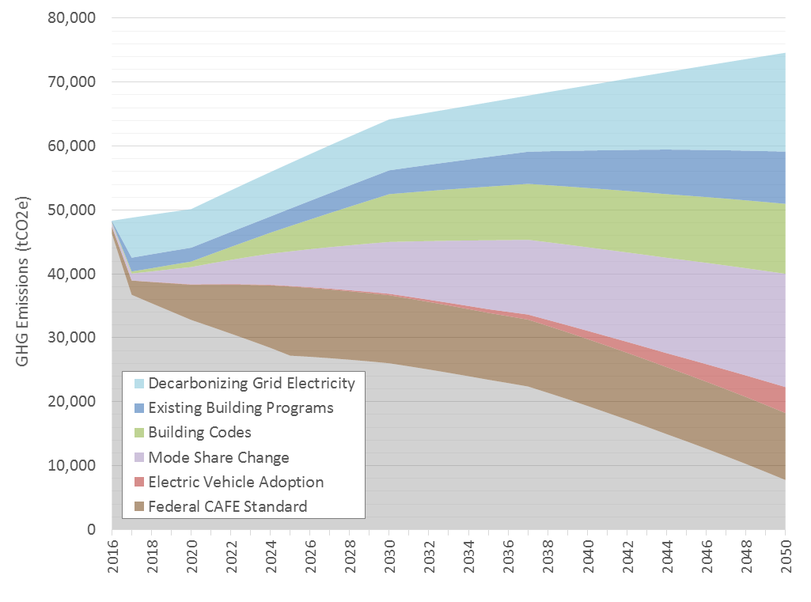

Figure 5 Transformation Scenario GHG emissions projection for East Arapahoe, with wedges representing emissions avoided or reduced.

1. The *EnergySmart Residential Program* was not applied because there is very little existing residential development in the neighborhood.
2. Estimated from data provided by InsideEVs, http://insideevs.com/heres-look-plug-electric-car-market-share-top-30-u-s-cities/.
3. Calculated using data available through Mapdwell, https://www.mapdwell.com/en/solar/boulder.
4. Building energy use is primarily based on energy use intensity (EUI) assumptions made in Boulder’s Climate Commitment Tool. EUI assumptions for later years have been made more conservative for this scenario. For example, the 2030 EUI for office buildings is 10 kBtu/square foot in this scenario, rather than the 0 kBtu/square foot assumed in the Tool. EUI assumptions are frozen from 2030 onward.
5. The natural gas-to-electricity conversion rate used for these projections can be updated by the City with additional information on energy end uses in buildings and equipment energy factors. See here for a discussion of how fuel switching can lead to overall energy use reductions depending on building systems: <http://cleantechnica.com/2016/05/23/fuel-switching-essential-step-towards-decarbonized-future/>.
6. Battery electric vehicles (BEVs) are powered entirely by electricity from the grid, while plug-in hybrid electric vehicles (PHEVs) are powered first by grid electricity, then a hybrid engine that relies on another fuel source (typically gasoline or diesel) once the battery is depleted. This scenario assumes 75% of electric vehicles adopted are BEVs and 25% are PHEVs.