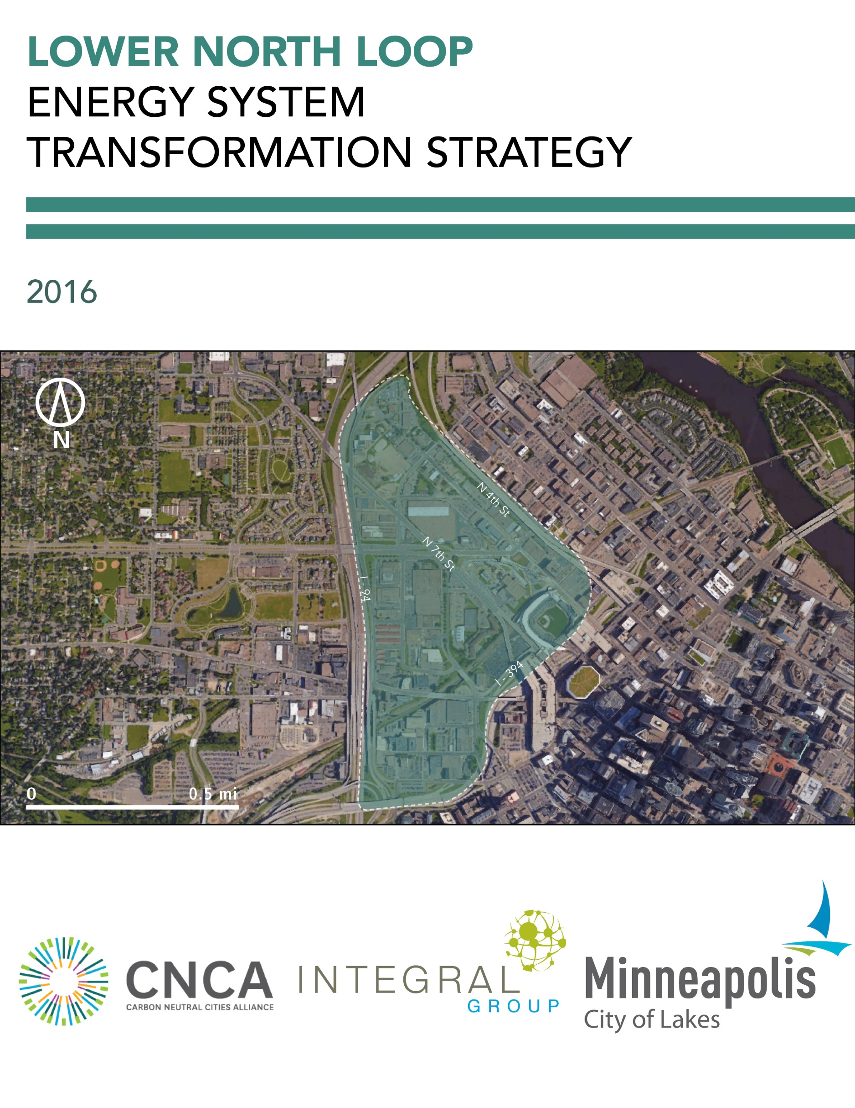

TABLE OF CONTENTS

1 Introduction 1

2 Shifting Minneapolis Towards Zero Emissions 3

2.1 A Solid Foundation 3

2.2 Sustainability for All 4

2.3 Sphere of Influence 4

2.4 A Changing Climate 5

3 Neighborhood | Lower North Loop 7

4 Fostering an Energy System Transformation 8

4.1 Baseline Energy and Emissions Profile 8

Energy Supply 8

Buildings 9

Transportation 9

Summary 10

4.2 Transformation Scenario and High Priority Actions 12

Energy Supply 13

Buildings 16

Transportation 20

Summary 23

# Introduction

Cities across the world are beginning to take climate change seriously, and are implementing a range of strategies, policies and programs to dramatically reduce their greenhouse gas (GHG) emission contributions into the atmosphere. To avoid a catastrophic level of global warming, these innovative urban centers have pledged to reduce their emissions by 80% by the year 2050, with a longer term target of relying on 100% renewable energy in all aspects of urban life.

To make this transition will require a considerable transformation in the way we work, live and commute, as well as a new way of thinking about and designing our cities. As a starting point, many local jurisdictions are focusing their efforts on the transformation of individual neighborhoods as a way of piloting novel planning tools, development models, and engagement methods. While many of the plans and policies required at the neighborhood scale are applicable to urban systems more broadly, others must be tailored to the unique context and circumstances of a particular area. Existing energy infrastructure, building types, transportation networks, levels of community engagement and many other dimensions need to all be considered in weighing the various approaches to decarbonization to ensure the right fit and highest level of success.

With funding from the Carbon Neutral Cities Alliance (CNCA), Integral Group collaborated with the cities of Boulder, Minneapolis, and Seattle in 2016 to develop a step-by-step guide, the Energy System Transformation Playbook (Playbook), to help municipal governments develop an Energy System Transformation Strategy. These strategies are intended to help municipal governments take the steps necessary to foster a transition towards zero emission, resilient, equitable, and decentralized energy systems that can power cities long into the future (as characterized in Figure 1). More information on what comprises a city’s or neighborhood’s energy system and what it will take to foster a transition can be found in the Playbook.



Figure 1 The key dimensions of an energy system transformation, as taken from the Energy System Transformation Playbook. See the Playbook for more information.

To assist in the development of the Playbook, a draft version of the Playbook was applied to a neighborhood in each of the cities involved in the project. The purpose of applying the Playbook to these neighborhoods was to test its content and process, then collaboratively evaluate the application to determine required adjustments for usability and effectiveness. Lower North Loop was used as the test neighborhood in Minneapolis, and this Lower North Loop Energy System Transformation Strategy is the result. The content of the Strategy, including energy and emissions projections, was developed by Integral Group with input from City staff. This Strategy is not intended to represent the City’s perspectives on how the neighborhood will develop (e.g. changes in density, development rates). The recommendations are based on Integral Group’s analysis and the guidance provided in the Playbook. The team did not conduct stakeholder engagement and the recommended strategies and actions are not intended to represent the perspectives or priorities of the City or other stakeholders.

Rather, this Strategy should be viewed as an example analysis of what it will take for a city or neighborhood to eliminate GHG emissions from its energy system (i.e. decarbonize), both in terms of the types of actions and the scale of effort required. The City of Minneapolis can use the Strategy and the associated Playbook to inform discussions among City staff and other stakeholders regarding what the City must achieve to transform its energy system to mitigate climate change, among other priorities. The Strategy includes an analysis of and resulting strategies and actions for the three urban systems that comprise a city’s energy system:

* **Energy Supply**, including both grid-supplied and smaller on-site or district scale energy sources;
* **Buildings**, including both new construction and existing buildings, and;
* **Transportation**, including the reduction of fossil fuel-based automotive modes of transportation and the support of alternative means, such as cycling, walking, and public transit.

The Strategy should be used in conjunction with existing plans and policies at both neighborhood and city scales. The contents of the Strategy include:

* A description of the context of Minneapolis as it is relevant to the process of decarbonization, including any barriers or opportunities;
* A description of the neighborhood of Lower North Loop, including current and projected development profiles;
* A description of the neighborhood’s current energy and emissions profile, including the broad trajectory required to transition to zero carbon; and
* A list and explanation of relevant strategies and actions to be taken over the next 5-10 years.

# Shifting Minneapolis Towards Zero Emissions

A process of decarbonization in the city of Minneapolis will be facilitated by a number of existing structures and actions. To begin, the city’s political system is characterized by a weak-mayor/strong-council form of government, with twelve council members belonging to the Democratic-Farmer-Labor (DFL) Party of Minnesota and one to the Green Party. This political leadership and the accompanied support of the public has contributed to a long history of greenhouse gas emission reduction strategies, beginning with the adoption of the *Minneapolis/Saint-Paul* *Urban CO2 Project Plan* in 1993.

More recently, Minneapolis formed the *Minneapolis Clean Energy Partnership*, a partnership between the City and its electric and gas utilities, Xcel Energy and CenterPoint Energy. The intent behind this formal relationship has been to align the carbon reduction objectives of the energy utilities with those of Minneapolis, as well as the State of Minnesota’s renewable portfolio standard. Although this partnership ultimately limits Minneapolis’ independence in terms of its own energy supply, it forces private energy companies to seek innovative ways of reducing carbon emissions, while increasing investment in renewable energy technology.

These carbon reduction efforts have been also substantiated by Minnesota’s *Conservation Improvement Program*, which requires public utilities to invest a portion of their revenues in projects designed to reduce their customers’ energy consumption and improve energy efficiency. In addition to these existing actions and powers, Minneapolis’ large-scale wind capacity has increased by a factor of 10 between 1999 and 2011, demonstrating the city’s potential to scale up its renewable energy generation. Wind energy currently provides 17% of the state’s renewable energy portfolio. The *Energy Innovation Corridor*, a transportation and energy showcase along an eleven-mile light rail route between downtown Minneapolis and downtown St. Paul, has further encouraged innovation through energy efficiency strategies, renewable energy production, clean transportation, and smart technologies.

## A Solid Foundation

To take a city through the energy system transformation requires resources. Fortunately, the city of Minneapolis has a strong economic base, ranked thirteenth in terms of GDP across the U.S. Its economy is derived from commercial, financial, rail and transport, health care, and industrial sectors, making for a rich and diversified economy and the creation of several job opportunities across the city. With an unemployment rate of 2.8%, Minneapolis sits well below the U.S. national average of 5%. Its population is well educated, with 47% of the population over 25 years of age in possession of a bachelor’s degree or higher, providing a labor force well-suited for complex energy system transformation.

The City has furthermore taken advantage of the *Energy Efficiency Community Block Grant* developed under the 2009 American Recovery and Reinvestment Act in order to stimulate economic development while encouraging the uptake of energy efficiency and renewable energy technologies. The strategies deployed under this program have further stimulated its economy by providing loans and microgrants for carbon reduction actions, job training within the renewable energy sector, and cost savings through support for building energy audits.

The City’s existing support programs and technological capacity will also support the transformation, enhanced by the presence of Mortenson’s headquarters in Minneapolis, an industry leader in wind turbine installations. Although solar energy generation has been relatively less productive, Minnesota Community Solar currently provides opportunities for residents to either provide land for a solar garden, or to purchase electricity from solar gardens installed elsewhere. Minneapolis experiences an average of 198 sunny days during the year, which is less than the U.S. average of 205, but solar still remains a viable source of energy generation. The Minnesota Solar Suitability Analysis App allows residents of Minnesota to evaluate their solar potential and determine whether it is something they would like to pursue. The *Made in Minnesota Solar Incentive Program* also provides incentives for consumers who install PV and solar thermal systems using solar modules and collectors certified as manufactured in Minnesota.

## Sustainability for All

The cost of living, including the cost of electricity, is another important dimension of the energy system transformation. Minneapolis’ residential and commercial electricity rates are already lower than the national average, but the average industrial electricity rate is greater – a potential cost barrier when switching to higher use of low and no-carbon electricity. Minneapolis also continues to experience high levels of inequality, with a Gini coefficient of 51.1 and 22.6% of its population in poverty. This trend is particularly evident in homeownership disparities among racial and ethnic groups, likely to be worsened with the disappearance of entry level homes in favor of higher-end properties over $1 million. The recent housing affordability index also indicates increasing housing prices relative to income. Addressing these racial, ethnic, and socio-economic inequalities is therefore important to address in the design of carbon reduction strategies, as little progress can be made if the basic needs of residents are not first met.

## Sphere of Influence

The approaches a city selects to undertake an energy system transformation depend partly on the extent of their influence or control over the urban system component in question. Municipal powers over different assets, functions, or decision-making structures vary according to their jurisdiction and circumstances. While one city may have full control over their building code, others may be required to conform to state regulations over building form and energy efficiency.

The CNCA Playbook offers a *sphere of influence mapping* tool to help cities determine their priority energy system transformation strategies based on the level of control or influence they have over each of the key urban system components. The extent of a municipal government’s influence can be determined by placing it into one of three broad categories:

* **Control:** Where a city has near-complete or full decision-making authority over components of the urban system or issue in question.
* **Influence:** Where a city has no decision-making authority, but has access to resources and forums that can be used to influence decision-making by market actors or other levels of government.
* **Interest:** Where a city has neither control nor direct influence over components of the urban system, but is interested in and possibly affected by the outcomes of decisions made by other actors.

Minneapolis has moderate influence over its energy supply, through an agreement with its utilities, but is limited in its ability to transform buildings because the building code is regulated by the state government. As such, it has a limited level of control over energy system transformation relative to the other cities analyzed during this exercise (Boulder, CO and Seattle, WA). Figure 2 on the next page indicates the City’s level of control over each component of each urban system designated by the cells with orange borders. For each urban system component, Minneapolis can take action on the decarbonization priorities listed in the box with orange borders, as well as the cells in the same row to the left of the box. This tool thus provides insight on what the City can and should prioritize to progress the energy system transformation for each urban system component. It was used to inform the priority actions presented in this Strategy. Refer to the Playbook for more information on sphere of influence mapping and the decarbonization phases in Figure 2.

## A Changing Climate

Finally, the climate of Minneapolis may also influence efforts to decarbonize. The city’s climate is characterized by a wide range of temperatures – from an average of 15.6°F in January to 73.8 °F in July. These conditions will require special consideration when approaching building efficiency strategies, given the fluctuations in temperature and consequent building conditioning required. Further, given that Minneapolis’ annual average temperature is projected to increase between 5.4°F and 7.2°F above the 1970 to 1999 baseline under upper mid-range emissions projections, building conditioning and energy use will be a critical component of carbon reduction strategies. Minneapolis’ urban fabric is also conducive to the Urban Heat Island Effect, with warmer temperatures found in the city relative to surrounding rural zones. This is relevant for energy loads, particularly when considering average nighttime temperatures in both summer and winter are projected to increase more than daytime temperatures.

|  |  |  |  |  |  |  |
| --- | --- | --- | --- | --- | --- | --- |
| **Energy System Transformation Phases** | | **Working without Control:** Act where possible + Acquire more control where feasible + Lobby for Implementation of Phases 1-3 | | **Phase 1:** Initiate Energy System Transformation | **Phase 2:** Strategically Decarbonize | **Phase 3:** Zero Emission Energy System |
| **Level of Control** | |  |  |  |  |  |
|  |  |  |  |  |
|  |  |  |  |  |
| **INTEREST** | **INFLUENCE** | **CONTROL** |  |  |
| **ENERGY SUPPLY** | **Grid-Supplied Energy**  **(*Imported*)** | * Increase purchases of clean energy where possible * Conduct outreach campaigns | * Explore/develop MOU with electrical utility to increase clean energy supply | * Procure zero emission energy directly (e.g. power purchase agreements, community choice aggregation)or indirectly (e.g. renewable energy credits) | * Increase zero emission energy supply * Phase out indirect purchases (e.g. renewable energy credits) | City runs on 100% zero emission energy |
| **Neighborhood-Scale Energy**  **(*Local*)** | * Provide programs and incentives * Conduct outreach campaigns * Encourage organizations to procure clean energy * Decarbonize city-owned generators * Increase internal capacity * Purchase clean energy where available | * Use existing powers (e.g. right-of-way) to leverage low emission DES * Use zoning powers to compel low emission DES studies for large developments | * Develop or require development of low emission district energy systems * Require certain new buildings to connect to district energy systems | * Transition from low emission to zero emission DES * Prioritize connection of existing loads to direct energy systems | High intensity loads are served by zero emission district energy as needed |
| **On-Site Energy**  **(*Local*)** | * Provide programs and incentives * Conduct outreach campaigns * Offer bulk buy programs * Increase internal capacity * Install on-site generation at city facilities | * Update regulations to support on-site energy generation | * Evaluate potential for zero emission on-site thermal systems * Develop a renewable energy proliferation strategy * Lobby for authority to allow peer-to-peer energy transactions | * Establish peer-to-peer energy transactions as a key part of the city’s energy market * Implement an on-site renewable energy strategy | Grid-supplied and neighborhood-scale energy supplemented by desired level of on-site generation |
| **Grid Modernization** | * Develop internal capacity to understand grid modernization and its relationship to achieving climate and energy objectives | * Work with utilities to install advanced metering infrastructure | * Require buildings to install advanced meters * Study grid’s ability to host distributed energy resources (with utility) * Lobby state and electric utility to incorporate distributed energy resources into planning | * Develop a location-based profile of energy and emissions * Implement and support pilot projects * Work with state to allow and develop a peer-to-peer energy market | Highly efficient grid capable of supporting desired level of distributed energy resources |
| **BUILDINGS** | **New Buildings** | * Offer incentives * Coordinate bulk buy programs * Support building sector training * Pilot technologies * Study thermal and industrial decarbonization options | * Integrate GHG emissions performance into ‘up-zoning’ and programs | * Develop a roadmap to zero emission building (ZEB) codes * Map trajectory to ZEB performance * Develop Incentive programs with utilities for ZEBs | * Implement ZEB building codes | All new buildings required to be zero emissions |
| **Existing Buildings** | * Provide decarbonization and efficiency programs and incentives * Support building sector training * Pilot technologies * Study thermal and industrial decarbonization options * Implement municipal energy management program * Increase internal capacity | * Explore/develop MOU with utilities to decarbonize buildings | * Offer incentives for decarbonization * Enact a building energy reporting and benchmarking policy * Integrate GHG emissions into retrofit requirements * Develop incentive programs with utilities for ZEBs * Offer decarbonization incentives | * Retrofit all existing buildings to eliminate fossil fuel dependency | All existing buildings retrofitted to operate on zero emission energy |
| **TRANSPORTATION** | **Mode Share** | * Apply transit-oriented development planning * Promote transit, cycling, walking, and tele-working * Support pilot projects and reduce regulatory barriers for new technologies | * Increase attractiveness of non-auto modes * Invest in bicycle sharing * Redevelop neighborhoods into “complete” streets * Redesign goods movement | * Develop non-auto mode infrastructure * Implement road use charges for fossil fuel vehicles | * Expand non-auto mode infrastructure to increase coverage and demand | Multi-model transportation network offers people multiple zero emission options |
| **Zero Emission Vehicles and Fuels** | * Coordinate bulk buy programs * Convert fleets to low- and zero-emission vehicles * Encourage adoption of low- and zero-emission vehicles (ZEVs) | * Develop partnerships for ZEV car share * Develop partnerships for electric vehicle infrastructure * Support shift from trucks to rail * Lobby state government to mandate ZEV sales | * Install electric vehicle (EV) charging infrastructure in high priority locations * Require EV charging infrastructure capabilities in buildings and parking lots * Incentivize ZEV ownership | * Require vehicle charging stations in buildings and parking lots * Adjust ZEV incentives based on costs and market adoption * Disincentivized fossil fuel vehicle ownership | All vehicles run on zero emission fuels |

Figure 2 Minneapolis’s level of control for each urban system component according to the Playbook’s sphere of influence mapping tool.

# Neighborhood | Lower North Loop

Although this Strategy’s framework is intended for a variety of contexts within Minneapolis, the focus of preliminary efforts in transforming the city towards zero carbon is the lower portion of the North Loop neighborhood, located north of Highway I-394, and bordered by Highway I-94 to the west and by North 4th Street to the east (Figure 1). Under the transect framework, the current state of the neighborhood can be qualified as a “Special District”, in that its industrial character does not conform to the characteristics outlined in any of the Transect Zones. However, the long term vision for Lower North Loop’s redevelopment aligns closer with that of a T-5 Urban Center Zone, given the proposed mix of mid- and high-rise development, despite remaining outside of Minneapolis’ downtown core. Further, the proposed increase in residential land use supports the transition of Lower North Loop from a primarily light industrial area to a highly diverse neighborhood with some full-time residents. The proposed improvements to the urban street grid, pedestrian and cycling network, green infrastructure, and diversity of housing, office and retail, all support the evolution of Lower North Loop as an Urban Center.

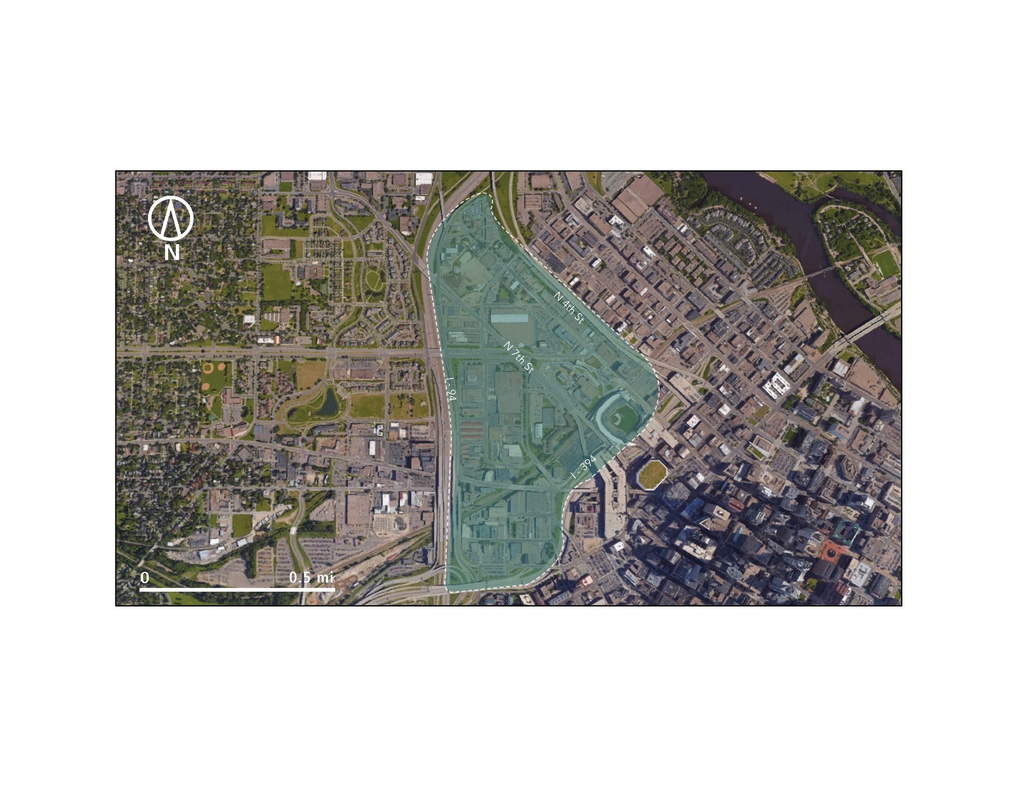

*Figure 3 Map of Lower North Loop neighborhood in Minneapolis, Minnesota.*

The plans for this future neighborhood are centered on the continued development of the existing farmer’s market and the clusters of development in its proximity, as well as a vision of new parks, greenways, transit lines and pedestrian connections that will provide necessary civic space and transportation needs for residents. The neighborhood’s current proximity to Target Field also requires special consideration, given the periodic fluctuation of residents into the area and the potential of the sporting venue to be an important magnet for future redevelopment. Connectivity within the neighborhood is also a concern, as it is currently underserved by public transit. However, Minneapolis’ control over pedestrian and cycling infrastructure, as well as the public transit network through Metro Transit, indicates that Lower North Loop can be designed to encourage active and public transit use.

# Fostering an Energy System Transformation

The remainder of this Strategy presents two energy and emissions scenarios: a *Baseline Scenario* assuming business-as-usual activities, and a *Transformation Scenario* developed to eliminate GHG emissions from the neighborhood. We used the *Transformation Scenario* alongside the CNCA Playbook to identify the City’s top priorities in each urban system—energy supply, buildings, and transportation—to decarbonize the neighborhood. We discuss these priorities alongside strategies and actions drawn from the Playbook. Energy consumption and GHG emissions are quantified for both scenarios.

Recall that this Strategy is intended to help inform discussions between City staff and other stakeholders regarding what the City must achieve to transform its energy system to mitigate climate change, among other priorities. This Strategy does not present a specific plan to achieve decarbonization, but rather identifies top priorities and the strategies and actions the City can use to achieve them. Readers should view the *Transformation Scenario* and associated priority strategies and actions in this light.

## Baseline Energy and Emissions Profile

To understand what actions are required to bring Lower North Loop, or any other neighborhood, to a state of zero emissions, it is important to first understand its current state. Development in the Lower North Loop neighborhood has the potential to grow significantly over the next 25 years, which of course represents only one potential growth path. For this exercise, we assume the neighborhood grows at a 2% annual growth rate. Under this scenario, total square footage is projected to grow from approximately 4.9 million square feet to 8 million square feet by 2040. Eighty-four percent of the neighborhood’s current square footage is commercial, industrial, and institutional; moving forward, new mixed-use developments at medium to high densities will steadily grow the portion of residential buildings, which are assumed represent 40% of total square footage by 2050. The changing composition of the neighborhood towards increased residential will push natural gas to play a larger role in future GHG emissions, while increased jobs and new housing in the area will drive increases in transportation demand and associated gasoline and diesel consumption. The resulting energy consumption and GHG emissions are presented in Table 1.

In addition to new development, the neighborhood’s energy and emissions are affected by existing policies and programs, as well as assumptions about the future electricity mix and transportation demand.

### Energy Supply

* Current and future electricity GHG intensity is based on Xcel Energy’s *Current* *Preferred Plan*.[1] Under the scenario modeled here, electricity is assumed to be approximately 46% less GHG intensive in 2050 than today. The *Current Preferred Plan* is projected to satisfy both the Minnesota Renewable Energy Standard and federal Clean Power Plan.

*Table 1 Summary of current and future energy consumption and GHG emissions in the Baseline Scenario.*

|  |  |  |  |  |  |
| --- | --- | --- | --- | --- | --- |
| GHGs (tCO2e) | Current | 2020 | 2030 | 2050 | % Change from Current by 2050 |
| Total* | 93,700 | 89,000 | 81,100 | 88,100 | -6% |
| *by sector* |  |  |  |  |  |
| Buildings | 46,900 | 43,700 | 37,400 | 40,000 | -15% |
| Transportation | 46,800 | 45,300 | 43,700 | 48,100 | +3% |
| *by fuel type* |  |  |  |  |  |
| Electricity | 35,200 | 31,500 | 22,900 | 25,200 | -28% |
| Natural Gas | 12,100 | 12,600 | 15,700 | 17,000 | +40% |
| Gasoline and Diesel | 46,400 | 44,900 | 42,500 | 45,600 | -2% |

|  |  |  |  |  |  |
| --- | --- | --- | --- | --- | --- |
| Energy Consumption (MMBtu) | Current | 2020 | 2030 | 2050 | % Change from Current by 2050 |
| Total* | 1,061,200 | 1,057,800 | 1,126,300 | 1,220,700 | +15% |
| *by sector* |  |  |  |  |  |
| Buildings | 443,700 | 459,800 | 552,600 | 592,900 | +34% |
| Transportation | 617,500 | 597,900 | 573,600 | 627,800 | +2% |
| *by fuel type* |  |  |  |  |  |
| Electricity | 218,700 | 225,000 | 261,400 | 287,600 | +32% |
| Natural Gas | 227,500 | 237,600 | 259,600 | 320,700 | +41% |
| Gasoline and Diesel | 615,000 | 595,100 | 569,300 | 612,400 | 0% |

*Numbers may not sum due to rounding.

### Buildings

* The *Baseline Scenario* assumes that Minnesota’s building code will continue to follow the International Energy Conservation Codes (i.e. become more stringent until 2030, then remain static until 2050).

### Transportation

* Passenger vehicle fuel efficiencies are assumed to steadily improve until 2025 as a result of the federal Corporate Average Fuel Economy (CAFE) Standard, then remain static.
* Electric vehicle (EV) adoption increases are based on assumptions about EVs’ share of new vehicle sales in each year. This is currently approximately 0.3%[2] and is assumed to grow modestly to 5% by 2030, 10% by 2040, and 20% by 2050.
* Transportation demand (vehicle miles traveled, VMT) is assumed to grow alongside growth in the building stock, but at a slower rate.[3]
* Mode share is assumed to stay approximately constant at 84% passenger vehicle, 8% transit, and 8% cycling and walking.
* Current and future transportation demand are assumed to increase linearly with growth in square footage. There was insufficient transportation demand and building data to calculate future transportation demand and mode share based on the building types and associated job and housing numbers. Guidance on calculating trip generation was obtained from the Institute for Transportation Engineer’s *Trip Generation Manual*.

### Summary

While moderate growth in the building stock and associated transportation demand will drive increases in energy consumption and emissions, the policies, programs, and assumptions listed above will have a downward or neutral effect on energy and emissions. The cumulative effect of these pressures on energy and emissions is summarized in Table 1 above.

The emissions impact of the programs, policies, and assumptions in each sector is summarized in the wedge diagram in Figure 4, where each colored wedge represents avoided GHG emissions. The total emissions *without* these programs, policies, and assumptions are represented by the top of the wedge diagram, which shows that emissions are approximately 27% higher in 2050 than in the present day. The grey area at the bottom of the diagram represents remaining emissions *after* the programs, policies, and assumptions have been applied, which are approximately 6% lower in 2050 than today. The difference in emissions in these two 2050 projections is due primarily to the federal CAFE Standard (65%) and the Minnesota building code (32%). Remaining emissions reductions are the result of electric vehicle adoption (3%).

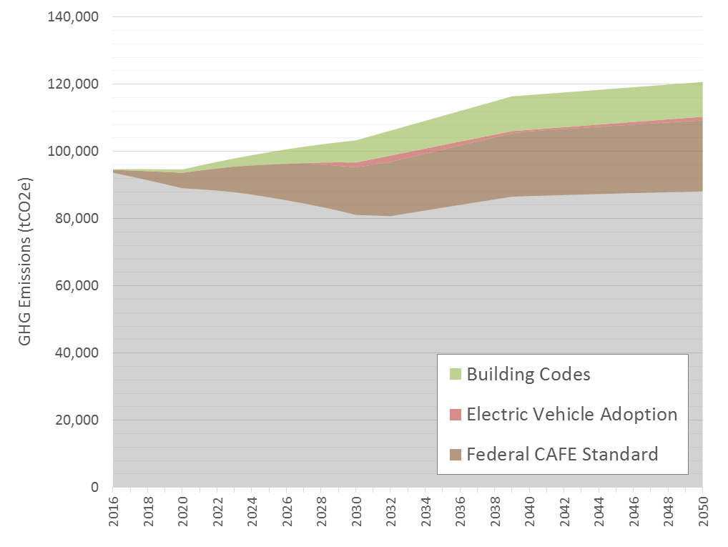

*Figure 4 Baseline Scenario GHG emissions projection for East Arapahoe, with wedges representing emissions avoided or reduced.*

## Transformation Scenario and High Priority Actions

Based on the assumptions modeled above, business-as-usual policies, programs, and technology adoption are projected to lead to lower GHG emissions by 2050 despite growth in energy demand from new development and increased travel. However, new action is required to place Lower North Loop on a path to zero emissions. To better understand what actions are required, a set of new policies, programs, and assumptions were modeled to decarbonize electricity supply, eliminate fossil fuel dependency in buildings and vehicles, and improve energy efficiency. The projected energy and emissions of this *Transformation* Scenario are summarized in Table 2. The remainder of the section identifies priority focus areas for each urban system, discusses the *Transformation Scenario*, and lists relevant strategies and actions from the Playbook that can help the City decarbonize the neighborhood.

*Table 2 Summary of current and future energy consumption and GHG emissions.*

|  |  |  |  |  |  |
| --- | --- | --- | --- | --- | --- |
| GHGs (tCO2e) | Current | 2020 | 2030 | 2050 | % Change from Current by 2050 |
| Total* | 93,700 | 85,600 | 68,900 | 31,400 | -66% |
| *by sector* |  |  |  |  |  |
| Buildings | 46,900 | 44,100 | 31,800 | 0 | -100% |
| Transportation | 46,800 | 41,500 | 37,100 | 31,400 | -33% |
| *by fuel type* |  |  |  |  |  |
| Electricity | 35,200 | 33,800 | 26,200 | 0 | -100% |
| Natural Gas | 12,100 | 11,100 | 8,800 | 0 | -100% |
| Gasoline and Diesel | 46,400 | 40,700 | 33,900 | 31,400 | -32% |
| District Energy | 0 | 0 | 0 | 0 | n/a |

|  |  |  |  |  |  |
| --- | --- | --- | --- | --- | --- |
| Energy Consumption (MMBtu) | Current | 2020 | 2030 | 2050 | % Change from Current by 2050 |
| Total* | 1,061,200 | 990,300 | 948,100 | 846,900 | -20% |
| *by sector* |  |  |  |  |  |
| Buildings | 443,700 | 445,600 | 466,500 | 390,900 | -12% |
| Transportation | 617,500 | 544,700 | 481,600 | 456,000 | -26% |
| *by fuel type* |  |  |  |  |  |
| Electricity** | 218,700 | 241,000 | 298,100 | 382,300 | +75% |
| Natural Gas | 227,500 | 209,400 | 165,000 | 0 | -100% |
| Gasoline and Diesel | 615,000 | 539,900 | 468,600 | 404,600 | -34% |
| District Energy | 0 | 0 | 16,400 | 60,000 | n/a |

*Numbers may not sum due to rounding.   
**Part of the increase in electricity consumption is due to fuel switching away from natural gas to electricity in buildings. A one-to-one conversion rate is applied, meaning 1 kBtu of natural gas becomes 1 kBtu of electricity after the fuel switch. The one-to-one conversion rate does not account for the fact that electrical appliances and systems (e.g. for cooking, heating) are more efficient than those using natural gas. In actuality, 1 kBtu of natural gas would convert to somewhere between 0.5 and 0.25 kBtu of electricity, depending on the appliance or building system and climate zone, among other things. However, not enough data about energy use and fuel mix was available to calculate the proper conversion rate. Therefore, a one-to-one ratio is used and can be considered a conservative assumption that causes electricity use to be overestimated.

### Energy Supply

|  |
| --- |
| Priority Focus to Achieve Decarbonization |
| * Continue pushing Xcel to decarbonize the electricity supply * Decarbonize and extend nearby district energy system to meet thermal loads that can’t be switched to electricity |

To decarbonize the Lower North Loop neighborhood, the City of Minneapolis must eliminate GHG emissions from its grid-supplied electricity. The *Transformation Scenario* assumes Minneapolis’ electricity supply follows Xcel Energy’s *Current* *Preferred Plan* until 2030, at which point electricity is steadily decarbonized until 2050. This could be supplemented by local renewable energy generation (e.g. solar panels), but these would only satisfy a small fraction of total electricity demand due to neighborhood’s density.

The Minneapolis Clean Energy Partnership between the City, Xcel Energy and CenterPoint Energy represents the city’s primary effort to date in shifting the electrical grid towards a low-carbon state. These efforts are critical to decarbonizing this and other neighborhoods in Minneapolis, and the City must continue to dedicate resources to decarbonizing the electricity grid to decarbonize Lower North Loop, as well as the rest of the city.

In terms of thermal energy, buildings in the neighborhood (and city) rely primarily on natural gas, which must be eliminated to decarbonize the neighborhood’s energy system. The higher density development of the neighborhood and high growth projections make the neighborhood a potential candidate for a local district energy system. This could take the form of a new zero emission system (e.g. waste-to-energy) or an extension of the existing district energy system serving the downtown core. If taking the latter approach, the existing district energy system would need to be shifted to a zero emission energy source for Lower North Loop to be decarbonized. The *Transformation Scenario* assumes that 2.0 MW of zero emission district energy can be brought online between 2025 and 2045 to meet part of the neighborhood’s building thermal energy demand.[4] Such a system may be necessary to replace any remaining natural gas that cannot be switched to electricity, including currently unknown energy needs in the neighborhood’s industrial buildings. The actual amount of zero emission district energy needed to service the neighborhood will depend on factors like how much thermal energy cannot be replaced by electricity and the City’s preference for increasing local district energy capacity versus fuel switching from fossil fuels to electricity, among other things. As such, the City should investigate building thermal decarbonization options and limits to electrification (including industrial energy needs), and explore whether decarbonizing and extending the existing district energy system is necessary and feasible.

Finally, as noted above, grid-supplied electricity can be supplemented with local generation (e.g. solar panels). This is not required for decarbonization, but can accelerate GHG emissions reductions in the neighborhood and yield other benefits that may be priorities for the City or other stakeholders (e.g. resilience, energy independence, local economic development). Installing local renewable energy generators (e.g. solar panels) may also increase support for the overall energy system transformation. Where opting to increase local distributed energy generation, the City will need to consider impacts on the electricity grid and undertake grid modernization actions to accommodate the distributed energy resources (these are not discussed in this Strategy).

To achieve these priorities, the City can apply and build on several strategies and actions from the Playbook.

**E.1. Enable consumers to purchase and/or produce renewable energy**

E.1.2. Assist large enterprises in implementing clean energy purchasing through PPAs and other arrangements

E.1.3. Ease permitting/land use regulation for on-site renewables (e.g. rooftop solar)

**E.5 – Ease regulatory compliance**

|  |
| --- |
| Example: District Energy in Fort Collins |
| The FortZED initiative introduced Smart Grid infrastructure to the Old Town section of Fort Collins, Colorado – enabling the integration and coordination of a system of mixed and distributed sources – with the intention of creating a net-zero energy district. The approach combines energy efficiency strategies with the expansion of renewable energy sources, reinforcing not only the district’s technological energy infrastructure, but also the capacity of local business to install, maintain, and operate these systems. |

E.5.1. Reduce regulatory barriers to zero emission neighborhood-scale energy systems (e.g. microgrids, district energy, tri-generation)

**E.7. Implement a renewable electricity proliferation strategy**

E.7.1. Invest in a city-run program to increase renewable energy generation by strategically targeting buildings, neighborhoods, businesses, and homeowners based on generation opportunities (e.g. rooftop suitability, electricity distribution capacity)

**E.8 – Develop a District Energy Strategy**

E.8.1. Assess thermal energy demand and local low carbon supply opportunities and use the results to develop a neighborhood-scale energy strategy that can inform other city policies and regulations and support specific infrastructure projects (e.g. energy system installations)

**E.9 – Invest in renewable supply**

E.9.1. Invest in neighborhood-scale energy generation (e.g. district energy, tri-generation districts), including through public-private partnerships

In addition to the actions above, renewable energy readiness and installation requirements could be placed on buildings if Minneapolis had control over its building code, or could influence Minnesota to add these requirements to the state building code.

Box 1 lists other actions the City could consider to support its energy supply priorities. As noted above, the City will also need to modernize its grid if adding significant amounts of renewable energy generation (e.g. solar panels) to the neighborhood. The Playbook provides strategies and actions the City can consider to support grid modernization. Action numbers (e.g. E.2.1) correspond to the strategies and actions table found in the Appendix of the Playbook.

|  |
| --- |
| Box 1 Other Relevant Energy Supply Actions from the Playbook |
| E.2.1. Implement a media, outreach, and communications strategy focused on increasing public awareness of efforts and specific programs and increasing adoption of programs  E.3.1. Coordinate and manage discount purchase opportunities (e.g. bulk buy programs) to increase consumer access to strategically important technologies (e.g. solar panels, air source heat pumps)  E.4.1. Provide financial incentives for on-site and off-site renewable generation (e.g. property tax breaks)  E.9.4. Invest in “community solar” projects  E.10.1. Install distributed renewable energy generation on city facilities  E.11.1. Establish or commission a city department or office separate from the city government to manage and implement renewable energy and energy performance programs  E.11.2. Provide a centralized online clean energy and energy efficiency commerce system that provides information on programs, access to financing and permits, and connection to support staff |

### Buildings

|  |
| --- |
| Priority Focus to Achieve Decarbonization |
| * Lobby the state government for zero emission building codes that eliminate dependence on fossil fuels, or for control over building code * Develop an innovative fuel switch retrofit program that eliminates fossil fuel dependency from all existing buildings * Investigate building thermal and industrial energy needs and decarbonization options |

To successfully achieve an energy system transformation, the City needs to eliminate GHG emissions from all new and existing buildings. This will require both new building codes and an unprecedented retrofit program that eliminates fossil fuels from all buildings while making them much more efficient. In many cases, eliminating fossil fuel dependency can be achieved by converting building systems and switching technologies so buildings are powered entirely by electricity. However, this will not be possible for all buildings. In particular, Minneapolis (alongside other cities) will need to investigate how best to decarbonize building thermal systems (which often rely on natural gas) and industrial buildings (which can have unique and specific energy needs).

Under a scenario with any significant amount of new development, Minneapolis’ lack of control over the building code will severely restrict its ability to enforce the kinds of policies necessary to shift the built environment towards zero emissions in a cost-effective and proactive manner. With population (and building square footage) growth expected to continue, Minneapolis must lobby the state government to implement a path to extremely efficient building codes that eliminate dependency on fossil fuels, or work to get control over its own building code. Without such power or actions by the state government, any efforts to encourage buildings to shift from natural gas to electricity will similarly be limited. As such, the priority actions listed below should be accompanied by active efforts to lobby the state government for a path to building codes designed for a zero emission future, or municipal authority over the building code.

|  |
| --- |
| Example: Zero Emissions Building Code |
| Brussels provides an example of a successful regulatory process that has shifted the Capital Region from among the lowest building insulation standards in the early 2000s, to one of the most stringent building energy codes in Europe today. The affordability and feasibility of Passive House standards were first demonstrated through the Exemplary Buildings pilot program (2007-2009), eventually leading to the adoption of the Passive House ordinance in 2009, which mandated all new public construction to follow Passive House standards by 2010, and all new construction and all retrofits to follow as of January 2015. This commitment by the local government was supported by the broader Energy Performance and Indoor Environment in Buildings Regulation, which adopted the targets of the European Energy Performance of Buildings Directive, requesting all buildings to be Nearly-Zero Energy Buildings by the end of 2020.  Dún Laoghaire-Rathdown, a county in the Dublin Region of Ireland, recently adopted its county development plan for 2016-2022, including an ordinance that requires all new buildings to be constructed to the Passive House standard. This standard restricts space heating and cooling energy demands, provides air tightness and thermal comfort requirements, and limits the primary energy demand of the entire building. These standards are achieved through a variety of building efficiency strategies, including: thermal insulation, passive house windows, ventilation heat recovery, airtightness of the building, absence of thermal bridges, as well as other innovative approaches, such as the solar orientation of the building, or the use of deciduous trees to provide shade in the summer and allow sunlight in the winter. |

The *Transformation Scenario* modeled here assumes the City follows a path to Net Zero Energy building codes starting in 2020, with maximum energy efficiency reached by 2030.[5] Significantly more energy efficient building codes will be required to prevent both further increases in energy demand and built-in fossil fuel dependency. Once built, the 3.1 million square feet of new buildings will stand for decades, and will require future retrofits at additional expense to shift away from fossil fuels at a later date. That said, the net zero energy codes modeled in this scenario were designed to be extremely efficient but *not* devoid of natural gas use. As such, the resulting retrofit requirements to eliminate fossil fuels provide a sense of the scale of action necessary to decarbonize the neighborhood’s building stock.

For existing buildings, the *Transformation Scenario* here assumes an aggressive retrofit program to eliminate any fossil fuel dependency (i.e. fuel switching retrofits) and make buildings more energy efficient (i.e. energy efficiency retrofits). Approximately 80% of natural gas is eliminated from buildings via retrofit programs that will affect approximately 3% of the building stock per year between 2017 and 2050. For most buildings, this can be achieved via a shift to electricity; for others, such as industrial facilities, it will require the use of alternative low-emission fuels, including district energy. Finally, as noted under Table 2, this scenario assumes all natural gas is shifted to electricity at a one-to-one rate, which likely causes an overestimation of projected electricity consumption due to the higher efficiency of electricity-powered building systems compared to natural gas-powered systems.[6] On top of fuel switching retrofits, this scenario also assumes that the City will implement an energy efficiency retrofit program that reduces building EUIs by 30%- to 50% in 2.5% of the building stock per year between 2017 and 2050.

Key challenges in eliminating GHG emissions from the built stock will include:

* The need to understand and identify explore opportunities to reduce energy use and emissions from both new and existing industrial buildings;
* The achievement of the drop in EUIs as proposed under net zero energy code for new construction, and;
* The achievement of aggressive retrofit rates in existing buildings that target both energy efficiency and fossil fuel dependency, as well as the need to run an effective fuel switching retrofit program.

Until the City has control over its building code, or the state government implements zero emission codes, the City will need to take advantage of strategies and actions that provide support and build capacity to encourage buildings to shift from natural gas to electricity. This includes leveraging existing powers wherever possible. Minneapolis’ cold climate will require that programs for both new construction and existing building retrofits focus on improving building envelope performance and raising required envelope R-values.

The Playbook offers several strategies and actions the City can pursue to reduce emissions from buildings while lobbying for zero emission building codes and developing a scalable fuel switching retrofit program.

|  |
| --- |
| Example: Retrofit Programs |
| Energiesprong is a program with its roots in the Netherlands that aggregates demand to deliver net-zero energy retrofit packages to existing social housing. The program organizes homeowners, contractors, and housing associations to provide a fully integrated platform – renovations can be completed in under a week and homeowners pay a monthly fee similar to their previous energy utility bill – all while eliminating home-sourced emissions, providing a return on investment, as well as a long term (30+ years) energy performance guarantee.  The New York City retrofit accelerator is another exemplar program that offers independent, customized technical assistant and advisory services at no charge to building owners to help facilitate the process of energy and water efficiency upgrades. |

**B.4 – Provide financial incentives**

B.4.1. Offer financial incentives to increase adoption of specific, strategically important technologies (e.g. to enable decarbonization)

**B.6 – Support/provide rewards for performance**

B.6.1. Provide regulatory and zoning relief (e.g. increased FAR, accelerated permitting) for projects meeting certifiable high standards (e.g. LEED)

B.6.2. Promote supportive market mechanisms such as building appraisal and mortgage underwriting that capture the value of investments in energy efficiency

**B.7 – Subsidize capacity improvements for building management**

B.7.1. Support efforts to train building operators in energy efficiency best practices

B.7.2. Invest in the sustainable buildings sector to improve the capacity of local or regional industry members to market, install, and maintain the technologies necessary for decarbonization

**B.8 – Expand capacity of efficient heating and cooling**

B.8.1. Develop and expand energy sharing networks for low- to zero-emission thermal energy systems

**B.9. Investigate options to decarbonize more challenging building systems**

B.9.1. Conduct a study to evaluate options to decarbonize thermal energy systems in buildings (both air and water)

B.9.2. Identify where industrial processes depend on fossil fuels and investigate options for decarbonization or deep GHG reductions

Box 2 lists other actions the City could consider to support its building priorities. Action numbers (e.g. B.1.1) correspond to the strategies and actions table found in the Appendix of the Playbook.

|  |
| --- |
| Box 2 Other Relevant Building Actions from the Playbook |
| B.1.1. Conduct building energy performance challenges  B.1.2. Promote building energy rating systems (commercial and residential)  B.1.4. Promote voluntary “stretch” building energy conservation codes and green-building principles by providing information and technical assistance  B.1.5. Promote “cool roofs”, air tightness testing, and other low-cost energy conservation approaches  B.1.6. Support best practice information sharing among building owners  B.2.1. Work with utilities to improve customer access to energy-use data  B.2.2. Conduct public education programs and campaigns that promote energy-saving measures  B.2.3. Promote green leasing for commercial buildings that enable a fair proportion of costs/benefits to be allocated to both tenants and landlords  B.2.4. Provide energy management resources to support organizations in managing energy and emissions (e.g. shared energy managers)  B.3.1. Coordinate and manage discount purchase opportunities (e.g. bulk buy programs) to increase consumer access to strategically important technologies (e.g. solar panels, electric vehicles, ASHPs)  B.5.1. Improve access to specialized financing to pay for efficiency improvements (e.g. green bank, PACE financing, carbon tax with distribution fund)  B.6.2. Promote supportive market mechanisms such as building appraisal and mortgage underwriting that capture the value of investments in energy efficiency  B.7.1. Support efforts to train building operators in energy efficiency best practices  B.7.2. Invest in the sustainable buildings sector to improve the capacity of local or regional industry members to market, install, and maintain the technologies necessary for decarbonization  B.8.2. Pilot new building technologies on city buildings  B.10.1. Implement Municipal Strategic Energy Management programs to decrease energy consumption and GHG emissions in municipal government buildings  B.10.2. Conduct deep retrofitting combined with installation of on-site renewable energy supply  B.10.3. Improve building operations and preventative maintenance  B.10.4. Improve energy efficiency of public/government-owned housing  B.10.5. Require all rehabilitation projects financed by city to include “green” capital needs assessment  B.11.1. Establish a city department or office separate from the city government to manage and implement renewable energy- and energy performance-focused programs  B.11.2. Provide a centralized online commerce system that provides information on programs, access to financing and permits, and connection to support staff  B.14.3. Require upgrades to commercial/industrial buildings’ lighting systems  B.14.4. Require higher standards for energy efficiency of appliances  B.14.5. Require energy performance check-ins and/or improvement actions (e.g. audit, recommissioning) at designated time intervals (e.g. every 5 years)  B.14.6. Require certification of building operators |

### Transportation

|  |
| --- |
| Priority Focus to Achieve Decarbonization |
| * Continue to increase focus on transit expansion and development oriented to transit, biking, and walking * Lobby state government for electric vehicle readiness in building code * Lobby state government to adopt California zero emission vehicle mandate |

As in other cities, reducing (and eventually eliminating) GHG emissions from Minneapolis’ transportation system will require a shift to zero emission vehicles and fuels, which can be supported and made more cost-effective through a shift to greater transit use, cycling, and walking, each of which can yield other benefits.

Minneapolis is in the midst of expanding transit infrastructure, has seen investments in cycling infrastructure drive high levels of cycling, and is increasingly focused on planning and building well-connected and transit-oriented neighborhoods and developments. Lower North Loop is one such neighborhood. The *Transformation Scenario* assumes the City will achieve its 2025 cycling target as set out in the *Minneapolis Climate Action Plan*, then steadily increase transit use, cycling, and walking to 2050. This includes targets of:

* 20% transit and 20% walking and biking by 2025, and;[7]
* 35% transit, and 25% walking and biking by 2050.

Ultimately, to decarbonize the neighborhood, all passenger vehicles will need to be shifted to zero emission fuel sources, of which electricity appears to be the most achievable and cost-effective. In this scenario, new vehicle sales are assumed to steadily shift to electric vehicles over time, accounting for 40% of passenger vehicles sold in 2030 and quickly rising to 100% of new vehicle sales by 2040. Some gasoline and diesel use is assumed to remain for three reasons:

* The model uses a simple algorithm that assumes only 4% of the vehicle stock is replaced with new vehicles each year, causing gasoline and diesel vehicles to remain on the road longer in the model than they are likely to in reality.
* The model assumes 25% of electric vehicles sold are plug-in hybrid vehicles with gasoline or diesel used as the second fuel.[8]
* This *Transformation Scenario* has not addressed fuel switching in transit vehicles or freight, which leaves some residual GHG emissions that will have to be addressed.

As in other cities, Minneapolis has limited power to increase vehicle availability and adoption, so must use its powers to increase market readiness and prepare for an electric vehicle future. This includes the provision of investments into installing the infrastructure necessary for a 100% electric vehicle future. Unfortunately, without control over its building code, the City is also limited in terms of its ability to increase electric vehicle charging availability in residences and workplaces, where the vast majority of electric vehicle charging occurs (>85%).

Based on these priorities and the City’s level of control over transportation, priority actions from the Playbook that the City should continue to focus on or begin focusing on include:

|  |
| --- |
| Example: Electric Vehicle Charing Requirements in Buildings |
| On the assumption that Minneapolis obtains the power to regulate building codes or can lobby the state for certain building code changes, there are several examples of cities enforcing a minimum number of electric vehicle charging stations for multi-family residential and commercial buildings (e.g. Vancouver, Los Angeles, San Francisco).  Otherwise, the provision of public charging infrastructure could also help to encourage plug-in vehicle ownership through increased confidence in the ability to operate their electric vehicles across the city’s geographic area. One leading example of electric vehicle use is Portland, Oregon, which has a generous network of charging stations, as well as a dedicated area of parking spaces reserved for plug-in cars in the downtown area, entitled Electric Avenue. |

**T.7 – Invest in increasing non-vehicle share of mobility**

T.7.4. Invest in bicycle sharing programs and public bicycle parking (coupled with requirements for buildings to provide bicycle space)

T.7.5. Invest in infrastructure for low- to no-carbon mobility: electric vehicle charging, hydrogen, fuel cell infrastructure (including incentives for real estate owners to install charging stations)

**T.8 – Invest in redesigned urban form/density to promote less use of vehicles**

T.8.1. Develop bicycle/walking infrastructure (citywide network)

T.8.2. Develop “complete”/green streets, walkable neighborhoods, and complete/green public spaces

T.8.3. Use transit-oriented development (TOD) planning and investments to increase neighborhood density and use of public transit

T.8.5. Redesign parking system regulations and infrastructure (e.g. eliminate/reduce parking spaces in high density/traffic areas)

**T.3 – Coordinate discount purchase opportunities for residents and businesses**

T.3.1. Allocate City staff time to coordinate and manage discount purchase opportunities (e.g. bulk buy programs) for strategically important technologies (e.g. electric vehicles)

**T.4 – Increase the cost of fossil-fuel vehicles and reduce the cost of carbon-free vehicles**

T.4.1. Establish congestion/climate taxes on fossil-fuel vehicles in designated areas

T.4.2. Establish taxes/fees on fossil fuel vehicles at purchase and/or registration

T.4.4. Provide zero emission vehicle purchase incentives (e.g. rebates/tax credits)

**T.6. Invest in decarbonizing public transit and municipal government fleets**

T.6.1. Convert public transit to no- to low-carbon energy (electric, hybrid, hydrogen)

T.6.2. Convert government fleets to no- to low-carbon energy

T.6.3. Encourage taxi fleets to transition to no- to low-carbon energy

While these actions will support a transition to electric vehicles, transitioning the passenger vehicle sector to electric vehicles is a large, complicated, long-term challenge that requires significant action. Given the limited power the City has in mandating vehicle or fuel emissions standards, the strategies and actions above must be just one part of the City’s strategy. The other part involves persistent and coordinated (e.g. with other cities) efforts to lobby the state government to take more action to increase electric vehicle uptake. The central focus of this lobbying should be on getting Minnesota to join California and eight other states in adopting California’s Zero Emission Vehicle Mandate (ZEV Mandate). The ZEV Mandate forces automakers to sell a minimum number of electric vehicles in the state each year or pay penalties, with the requirements steadily increasing and shifting towards more vehicles powered entirely by electricity (battery electric vehicles) and fewer vehicles powered by a combination of electricity and fossil fuels (plug-in hybrid electric vehicles). In doing so, it puts the onus on automakers to invest in the success of electric vehicles in the state, with the state’s major cities likely getting the most benefit.

Box 3 lists other actions the City could consider to support its transportation priorities. Action numbers (e.g. T.1.1) correspond to the strategies and actions table found in the Appendix of the Playbook.

|  |
| --- |
| Box 3 Other Relevant Transportation Actions from the Playbook |
| T.1.1. Promote the recreational and health benefits of bicycling and walking  T.1.2. Promote household financial benefits for reduced car reliance  T.1.3. Promote tele-working as an alternative to commuting  T.1.4. Promote carpooling and use of High Occupancy Vehicle lanes  T.2.1. Support pilots and address regulatory barriers for on-demand busing, shared use mobility, driverless vehicles, etc.  T.2.3. Implement smart-transit systems to provide up-to-the-minute transit/parking/travel information to residents  T.5.1. Establish regional road pricing (e.g. toll roads, dynamic pricing)  T.5.2. Promote automobile insurance options that reward drivers for driving less  T.5.3. Disincentivize off-street parking  T.7.6. Support shift of freight transportation from road to rail and ship  T.8.6. Redesign goods movement in city  T.9.1. Establish reduced idling ordinances |

### Summary

The impact these programs, policies, and assumptions have on emissions from each sector is summarized in Table 2 above and in the wedge diagram in Figure 5. As in Figure 4 above, each colored wedge represents the GHG emissions avoided or reduced by a set of policies, programs, or assumptions. In the *Baseline Scenario*, total GHG emissions are approximately 6% lower in 2050 than in 2016. The grey area at the bottom of the diagram represents those emissions that will remain after all existing programs, policies, and assumptions have been applied. In the *Transformation Scenario*, GHG emissions in 2050 are approximately 66% lower in 2050 than in 2016. As discussed above, all GHG emissions in 2050 are due to remaining gasoline and diesel consumption in the transportation sector. Altogether, 2050 GHG emissions may be underestimated by assuming that all natural gas in buildings can be replaced by electricity, and overestimated due to assumptions about electric vehicle adoption (noted above). Calculated from the top of the wedge in 2050, projected emissions reductions stem from decarbonizing the electricity supply (28%), shifting mode shares to increased transit, biking, and walking (23%), retrofitting and decarbonizing existing buildings (15%), and implementing net zero energy codes (14%). Relatively smaller emissions reductions are achieved through electric vehicle adoption (7%) and installing zero emission district energy supply (3%). Although small, both of these are necessary (or very likely necessary) to decarbonize Lower North Loop.

It should be noted that due to the complementary nature of some policies and programs, the relative size of different wedges can misrepresent the importance of certain actions. For example, the impact of electricity system decarbonization depends on fuel switching retrofits that shift buildings from natural gas to electricity. Similarly, the three wedges representing transportation account for the total GHG emissions reductions achieved in this urban system. The order of the calculations done in the model result in most GHG reductions being attributed to mode share and the CAFE standard, indicating that electric vehicle adoption has a limited impact. Done differently, the wedges could be different relative sizes. In actuality, decarbonization is only possible through a full transition to zero emission (e.g. electric) vehicles.

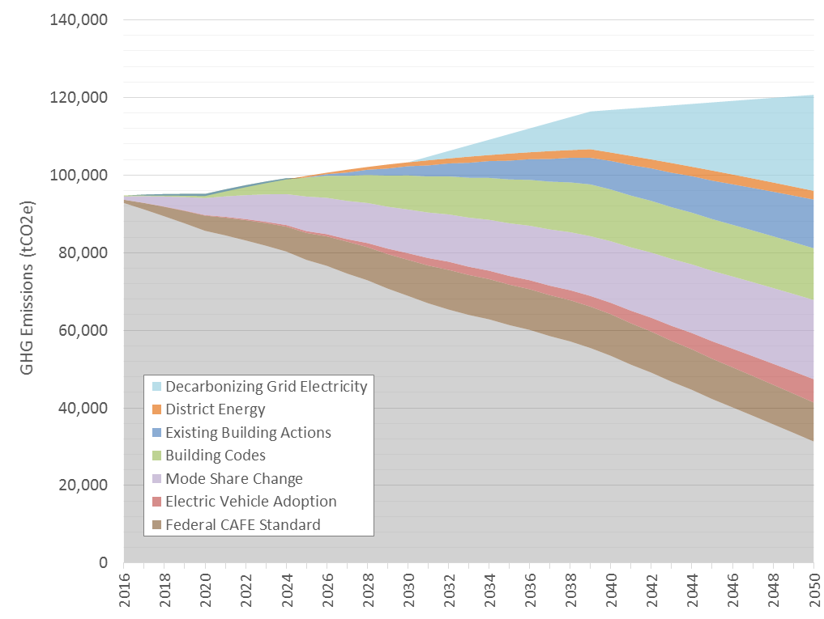

*Figure 5 Transformation Scenario GHG emissions projection for Lower North Loop, with wedges representing emissions avoided or reduced.*

1. Xcel Energy’s Upper Midwest 2016-2030 Resource Plan, Attachment B: Updated Strategist and Modeling Outputs, https://www.xcelenergy.com/company/rates_&_regulations/resource_plans/upper_midwest_2016-2030_resource_plan.
2. Estimated from The International Council on Clean Transportation’s *Assessment of Leading Electric Vehicle Promotion Activities in United States Cities*, http://www.theicct.org/sites/default/files/publications/ICCT_EV-promotion-US-cities_20150729.pdf.
3. The VMT growth rate was based on calculations done to calculate VMT growth in modeling for the East Arapahoe neighborhood’s Energy System Transformation Strategy for the City of Boulder. The growth calculation is based on a method used by the Institute for Transportation Engineers where VMT and mode share are the result of building uses (e.g. resident, commercial) and development typologies (e.g. low-rise, high-rise). Similar data was not available for Minneapolis.
4. The size of the system is based on eliminating natural gas from buildings that may not be addressed by fuel switching retrofits. Under this scenario, fuel switching retrofits eliminate approximately two thirds of baseline natural gas consumption in 2050 and the district energy system replaces the remaining third. The exact size of the system will depend on the thermal energy demand profile of the buildings.
5. Values used to define the code’s energy efficiency improvements are primarily based on Net Zero Energy code energy use intensity (EUI) assumptions made in Boulder’s Climate Commitment Tool. EUI assumptions for later years have been made more conservative for this scenario. For example, the 2030 EUI for office buildings is 10 kBtu/square foot in this scenario, rather than the 0 kBtu/square foot assumed in the Tool. EUI assumptions are frozen from 2030 onward.
6. The natural gas-to-electricity conversion rate can be updated with additional information on energy end uses in buildings and equipment energy factors. See here for a discussion of how fuel switching can lead to overall energy use reductions depending on building systems: http://cleantechnica.com/2016/05/23/fuel-switching-essential-step-towards-decarbonized-future/.
7. Minneapolis’ cycling target is 15% by 2025. This scenario assumes an additional 5% is walking.
8. Battery electric vehicles (BEVs) are powered entirely by electricity from the grid, while plug-in hybrid electric vehicles (PHEVs) are powered first by grid electricity, then a hybrid engine that relies on another fuel source (typically gasoline or diesel) once the battery is depleted. This scenario assumes 75% of electric vehicles adopted are BEVs and 25% are PHEVs.