Renewable Heating and Cooling

Best Practice Action Guide



Funded by the Urban Sustainability Directors Network and the Carbon Neutral Cities Alliance Innovation Funds

December 29, 2017



# Introduction

On-site fossil fuel combustion for thermal energy can account for up to 40% of emissions in some cities; for some cold-climate cities, thermal energy consumption in buildings can be the single largest source of community-wide emissions. Reducing greenhouse gas (GHG) emissions from thermal energy consumption in buildings is critical to achieving the long-term emissions goals of 80% reduction by 2050 held by leading cities across North America.

The cities of Boulder, Burlington, New York City, and Washington D.C. are in the process of developing long-term initiatives to drive the local scale-up of renewable heating and cooling (RH&C) technologies. These cities are exploring opportunities for using high-efficiency electric heat pump technologies—namely air source heat pumps (ASHP) and heat pump water heaters (HPWH)—in combination with increasing deployment of renewably-generated electricity to “decarbonize” their building sectors.

In order to establish policy strategies and develop internal roadmaps for action, these four cities conducted analyses of their local markets to better understand the state of their building stock and identify high-potential sites for near-term heat pump deployment. These parcel-by-parcel analyses focused on the nearly 1 million 1-4 family residential buildings across these cities, which (except for New York City) account for the majority of residential building emissions in these cities. Additionally, these buildings are likely to offer the highest potential for near-term deployment and be most responsive to city-led efforts to increase awareness and market deployment.

With technical support from DNV-GL, Meister Consultants Group, and Radiant Labs, the four cities collected and analyzed publicly-available data sources, including tax assessor, Census, and building, mechanical, HVAC, electrical, and other permit databases, as well as other data sets that could provide relevant information regarding resident demographics or clean energy deployment. Through these data analyses, the cities aimed to determine which 1-4 family buildings would have the highest potential for near-term adoption of ASHPs and HPWHs based on physical/building, economic, and demographic characteristics. Based on the results of these analyses, the four cities developed internal roadmaps for driving near-term action.[1]

This guide provides options and actionable steps for other cities interested in completing similar analyses to guide the development of approaches to transitioning away from fossil fuel-based heating. In particular, this guide discusses key steps and best practices to:

1. Establish goals and parameters for a thermal decarbonization initiative within the local context
2. Identify and collect data from publicly-available data sources
3. Conduct a market analysis of the local building stock
4. Leverage market analysis to engage key stakeholders and develop policies and programs for scaling the local RH&C market

Each city will have different goals and interests with respect to thermal decarbonization; varying levels of data availability across the building stock; and differing local energy policy and program contexts. As such, this guide focuses on high-level best practices that could be replicated in other cities, providing examples of the actions taken by the four cities over the course of the project.

This work was funded by generous grants from the Summit Foundation and Urban Sustainability Director’s Network. As part of the learning network developed through this project, there is a series of modules that were developed that explain more in detail how to develop an air source heat pump market, providing many case studies and examples. The modules and all project deliverables can be found here: [**Dropbox Link**](https://www.dropbox.com/home/USDN%20Funds/innovation%20fund/awards%20by%20type/gr_generalrfp/award%20projects/open/GR40_Renewable%20Heating_Cooling/Deliverables).

# Establish goals and parameters for a thermal decarbonization initiative within the local context

Cities across North America have established ambitious targets for reducing greenhouse gas emissions, though only a portion of these cities have determined clear roadmaps towards decarbonizing thermal energy in buildings. As a first step towards completing a data-driven market analysis, it is important to clearly contextualize a thermal decarbonization initiative within the local context.

In particular, consider some of the following key questions discussed below in planning an approach to thermal decarbonization:

* To what extent do buildings need to transition away from fossil fuel-based heating in order to meet your city’s long-term and interim climate goals?
* What is the current state of heating and cooling in your city? What are the primary heating fuels being used in your city?[2]
* What is the technology and market pathway for achieving this transition?
* What is the baseline awareness of the relevant renewable heating and cooling technologies in your city?What programs already exist to encourage deployment of RH&C technologies (e.g. incentive programs, financing options, etc.) and other related renewable energy and energy efficiency measures?
* What existing relevant targets and initiatives (e.g. around renewable electricity generation, electrification of transportation, building energy efficiency), as well as local constraints and limitations will affect how your city would approach its pathway to achieving thermal decarbonization?

While cities do not need to have completed the analyses necessary to answer these questions prior to completing other steps within this guide, having a thorough, holistic understanding of the goals and parameters of a thermal decarbonization initiative within the local context can help to inform the analysis.

The approach pursued by the four cities described below reflects an approach to thermal decarbonization within the broader, emerging framework of **strategic (or beneficial) electrification,** which aims to encourage the electrification of thermal energy (and transportation) sectors within the context of an increasingly-renewable electricity grid.

While strategic electrification is becoming a popular approach for driving thermal decarbonization, it is not the only approach available to cities. For example, depending on local context, some cities may be interested in leveraging other renewable heating and cooling technologies (e.g. solar thermal, bioenergy). However, given that the four cities involved in this project were focused on a strategic electrification-based approach to thermal decarbonization, most examples provided in this guide will focus on exploring the deployment of the high-efficiency heat pump technologies at the heart of this approach.

The strategic electrification framework, with examples on some of the approaches pursued by the four cities within that framework, is described further in below in Box 1.

Box . Strategic electrification and city pathways to deep decarbonization

|  |
| --- |
| **Strategic (or beneficial) electrification** describes an integrated approach to deep decarbonization driven by a conversion from fossil fuel-based end-uses to efficient electric-based technologies in a way that provides broader benefits (e.g. pollution, cost savings) to society beyond emissions reductions.[3] In particular, strategic electrification describes the electrification of thermal energy, transportation, and process heating, as well as other steps to improve the energy efficiency of these end uses within the context of an increasingly renewable electricity grid.  Strategic electrification is emerging as a leading approach to achieving deep decarbonization among some North American cities and states at the forefront of climate leadership, particularly given the initial successes and increasingly ambitious targets related to renewable electricity generation in some leading states. In the context of strategic electrification, thermal decarbonization typically refers to: 1) increasing deployment of renewable electricity generation; 2) improving the efficiency of buildings (e.g. through deep energy retrofits); 3) electrifying thermal energy consumption with high-efficiency heating and cooling technologies.  Thermal Decarbonization Pathway:  The four cities had previously completed various energy planning and roadmapping projects that identified high-efficiency heat pump technologies (especially air source heat pumps and heat pump water heaters) as the primary technologies of interest due in part to their scalability and relative cost-effectiveness, as well as (for ASHP) their ability to provide additional ancillary benefits such as high-efficiency cooling and improved indoor air quality.   * For example, in its Roadmap to 80x50, New York City estimates that achieving thermal decarbonization targets for the buildings sector will require that: 1) all buildings undergo a deep energy retrofit; 2) at least 50-60% of the city’s built square footage convert to heat pumps for space heating; and 3) at least 90% of the city’s built square footage convert to heat pumps for water heating.[4]   As such, guidance from these prior analyses helped the project team to focus the market analyses (as well as subsequent steps—e.g. to assess barriers and opportunities for heat pump deployment, leverage findings from the market analyses to design policies and programs) around more specific technology applications, including ductless and ducted ASHPs and HPWHs. |

# Identify and collect data from publicly available sources

Prior to conducting a data-driven market analysis to guide thermal decarbonization efforts, it was critical to **identify** publicly-available data sources that can provide valuable information about local buildings and their owners, as well as **collect and aggregate** these data for an in-depth building analysis.

Common data sets, as well as the relevant information that can often be provided, include:

* **Tax assessor’s data**, which can yield a range of information about a building including heating fuel type, heating distribution system type, availability of air conditioning, building size, and owner occupancy status.
* **Permitting data** (e.g. building, electrical, sheet metal, HVAC, mechanical, etc.), which can provide information on when a building owner has completed work related to heating/cooling system replacement, installation of solar PV and other clean energy technologies.
* **Census data**, which can provide information related to occupant demographics (e.g. income, education level) at the census block level.
* **Other relevant data** (e.g. energy program data, solar PV installations, demographics)**,** which can provide information on which building owners have participated in local or state energy programs or have adopted clean energy technologies in the past.

Determining what data are available is important to determining what questions can be addressed by this market analysis, what market analysis methodology can be completed, and what steps can be taken to build on this analysis. Critically, while publicly-available data sources can provide valuable information for this analysis, the availability and quality of these sources vary from city to city and may limit the level of analysis that can be performed. For example, some cities do not collect information (or have limited/unreliable information) related to heating fuels or do not aggregate or digitize data pertaining to a building permit’s intended scope of work. In general, higher quality and more granular data sources will yield a more robust market analysis.

Based on building, energy, and occupant data availability, your city may consider the following key questions:

* What are your city’s goals for the follow-on market analysis? What key questions could this analysis help to address? *(see next step for additional discussion)*
* What market analysis pathway could be selected based on the available data? *(see next step for additional detail on what data is necessary to support each pathway)*
* How could the available data potentially inform us about the state of building energy in your city?

# Conduct a market analysis of the local building stock

Once data sources have been identified and collected, a local market analysis can be completed.

Key questions often asked by city policymakers include:

1. What is the current baseline of heat pump installations in my city?
2. What is the potential for heat pump deployment in the buildings in my city?
3. Which building occupants would be most likely to adopt heat pump technologies?

A variety of approaches to analyzing the collected data can be taken to address these questions. In the four cities, the project team leveraged three approaches, which all established a rough baseline of installations then conducted analyses to determine the potential market for future technology deployment and the customer segments who would most likely adopt these technologies.

The approaches used include:

1. **MCG’s technology adoption index,** which focuses on identifying and mapping market segments that are most likely to adopt specific RH&C technologies based on building, economic, and demographic characteristics
2. **DNV GL’s analysis** on new technology adoption curves and end use survey data
3. **Radiant Labs permit scraping and mapping** software with GIS customer targeting tool

The methodologies for these approaches are summarize below.

1. **MCG’s Technology Adoption Index**

**Background and goals of the Index**

MCG’s approach, deployed in New York City and Washington D.C., focuses on using available data sources to provide city leaders with actionable information about their local building stock and homeowners in order to drive thermal decarbonization policy and program development.

While installations of RH&C technologies are technically feasible in most buildings, some aspects of these buildings could significantly increase installed costs and deter owners from adopting certain technologies. Thus, the goal of this approach is not to identify which buildings are technically feasible for a given technology, but rather to determine which building owners might be most likely to adopt a technology through assessing a variety of building and demographic factors that indicate the ease or affordability of installing a technology—or that its occupant might be more or less likely to adopt the technology. Given that RH&C markets are nascent or emerging in most cities, this market segmentation methodology seeks to identify the key market segments and buildings where city leaders can focus initial efforts to drive early adoption of the RH&C technology in question.

To provide this information, this approach:

1. Ranks data across key building and demographic indicators at the parcel level to reflect how the data impacts the ease, cost, or attractiveness of installing the technology;
2. Weights these indicators against each other based on relative importance to customer adoption, informed by past surveys and campaign results; and
3. Calculates an index value for each parcel reflecting the likelihood that its owner might adopt the technology.

While focused on ductless ASHPs, ducted ASHPs, and HPWHs in NYC and Washington D.C., this approach can also be applied to other RH&C technologies (i.e. ground source heat pumps, solar hot water, and modern central wood heating). This approach has been deployed in Boston, Somerville, Northampton, Portland and South Portland (ME), and Providence and will be deployed in seven other Massachusetts towns to inform the design and implementation of customer outreach and group purchasing campaigns. Note that indices are not comparable across cities or across technologies.

As with other market segmentation analysis approaches, this approach is more effective with high-quality, granular (parcel level) data, though the methodology can be adjusted based on available data. The results of this approach can also be mapped onto city parcels if GIS shapefiles are made available.

**Identifying and ranking building and demographic indicators**

Based on the available data, a number of key building and demographic indicators can be aggregated for use in the index. While these indicators can be limited or augmented based on the data available in each city, the indicators typically used in the analysis, as well as their typical sources and relevance to the analysis, are summarized in the table below.

|  |  |  |
| --- | --- | --- |
| **Indicator** | **Source** | **Relevance to RH&C Potential** |
| Heating Fuel Type | Assessor (parcel); census (block) | Existing fuel type is a primary driver for determining whether a RH&C installation is cost-effective. |
| Heating Distribution System | Assessor (parcel) | Some RH&C technologies will be cheaper/more straightforward to install depending on the existing heating distribution system. |
| Air conditioning | Assessor (parcel) | One of the primary benefits of air and ground source heat pumps is the ability to provide cooling with the same system. The availability of central AC could determine whether a homeowner might consider cooling to be an added benefit. |
| Heating System Replacement Year | Permit (parcel) | Homeowners may be less likely to install a RH&C technology if they have recently replaced their heating (or AC) system |
| Parcel/building size | Assessor (parcel) | The size of the building (e.g. square footage, number of floors, size of lot) can affect the cost of installing various RH&C technologies |
| Historic District/Landmarks | Assessor; historical district/ landmarks commission | Due to strict regulations related to modifying the exterior of buildings in historical districts, some RH&C technologies may be more challenging to install. |
| Building Type (SF/MF/Condo) | Assessor (parcel) | Installing a RH&C technology in a small multi-family building, particularly one that requires modifications to common spaces/building exterior, can potentially be more challenging. |
| Income | Census (block) | Higher income residents are more likely to be early adopters because they are able to afford a RH&C system that typically costs more than a fossil fuel-based alternative. |
| Basement | Assessor (parcel) | Availability of basement space can affect the cost or performance of installing some RH&C systems. |
| Owner Occupied (Y/N) | Assessor (parcel) | Building owners who occupy their buildings are more likely to make energy-related improvements they can benefit from. |

Additional demographic indicators from the Census or other sources (e.g. education level, age group) can be integrated into the index.

Data within these indicators are then ranked in order to develop a score (typically from 1-3) for each indicator. For example, homes heating with electricity or propane might receive a score of 3, homes heating with oil might receive a score of 2, and homes heating with gas might receive a score of 1, representing the relative cost-effectiveness of RH&C technologies against existing heating fuels. Rankings differ across technologies and typically adjusted from city to city based on data availability.

**Weighting indicators**

These ranked indicators are then weighted against each other based on relative importance to determining whether a homeowner will adopt the technology or how suitable their home is for the installation. Based on interviews with technology installers and market research, MCG developed a set of standard weights for each indicator, though similarly to rankings, indicators can be weighted differently depending on the local market context and goals of the city leader.

**Developing the index and supporting maps**

The rankings and weightings for indicators are combined to generate a score for each parcel reflecting the likelihood that the owner might adopt the technology.

The way indicators are ranked and weighted could be changed depending on the city’s goals; while the default approach focuses on identifying likely adopters, the approach can also be modified to focus on identifying populations that would likely need more direct support from the city to drive adoption (e.g. an “equity-based approach” focused on lower income residents).

Once results are generated, they can be mapped to a city’s GIS shapefiles to provide a spatially-oriented tool for city leaders. Example of Staten Island:

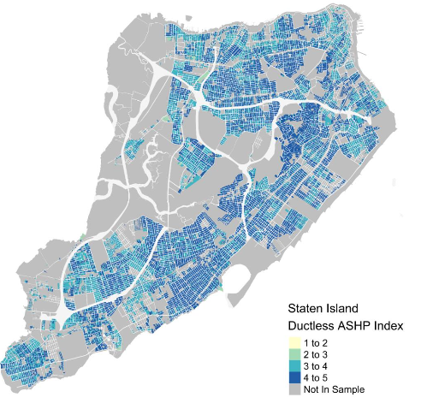

1. **DNV GL’s Renewable Heating and Cooling Analysis**
2. **Look at bigger picture** (# of residential housing units and publicly available data on heating fuels), consider natural lifecycle of technologies

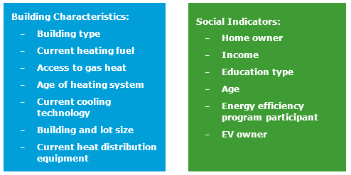

1. Radiant Labs conducts **Permit Data Analysis** (determined 202 air source heat pumps permitted since 2000)
2. **Consider variability of permit data.** A 2017 DNV GL study for CPUC, shows HVAC permit rate is between 8-29%[5] while water heaters are even less frequently permitted due to high DIY installation rates.
3. **Establish a baseline** of air source heat pump systems installed to date including a margin of error for space and water heating.

**Baseline Example:** Boulder Heat pump space heating 2017 baseline (number of homes with heat pumps)

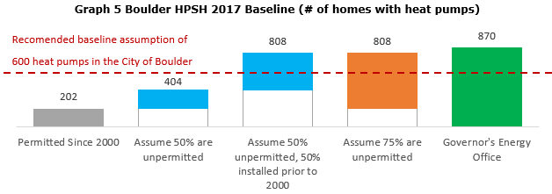

1. **Set heat pump/electrification** **targets overall**

**DNV GL target setting approach using technology adoption curve combined with natural replacement cycle of furnace and water heating systems:**

Programs targeted at switching constituents from natural gas to electric heating have only started in the past few years, with some states in the US still incentivizing fuel switching to natural gas. As such, the heat pump adoption curve displaying “what success looks like” is not available. Instead, we have looked at other recent energy efficiency technology shifts to determine what viable targets will be for the first ten years of the program. The chart below outlines the adoption curve of recent disruptive and green technologies:

**Adoption rates of disruptive and green technology**

Furnaces last 20 years. Therefore, if Boulder, for example, plans to electrify space and water heating systems by 2050 in step with increasing renewable energy on the grid, then every unit replaced from 2030 onward would need to be electrified, to meet GHG targets. The 2030 target of electrifying every unit at the natural replacement timeline would result in the electrification of 2,116 water heaters and 1,058 space heaters per year. Working backwards from that goal and using the technology adoption curve methodology described previously, the following chart outlines the annual targets for number of systems electrified within the City of Boulder.

RH&C Installation Target by Year

1. Determine GHG savings for this target

If all 40,000 of Boulder’s single family housing units decarbonized space heating/cooling and water heating systems, this would represent a savings of approximately 200,000 million cumulative tons CO2 (mtCO2e) saved by 2050.

**Annual emissions of residential thermal systems in Boulder**

1. **Determine Target by Customer Segment** using Radiant Labs software
2. **Radiant labs data aggregation and segmentation approach**

Radiant Lab’s has an iterative adoption and refinement approach that helps an efficiency program, such as the heat pump initiative, regularly course correct. This process requires three major steps:

## 1. Customer segmentation

Customer profiles or archetypes have been developed for the top priority potential customers in Boulder based on building characteristics, demographics, and social indicator analysis. Radiant Labs has developed a tool for use by the city, which can be used for ongoing market segmentation/targeting, monitoring, and evaluation. The tool includes county assessor’s data, permit data, building archetypes, census data, energy smart program data, as well as energy efficiency, solar PV, and other weatherization measure inputs. Radiant Lab’s tool will be used to effectively target and generate demand in each customer segment.

## 2. Boulder early adopter cohorts

In Boulder, there are several early adopter archetypes, or cohorts, representing the profiles of consumers who would be likely to adopt heat pump technology. Many of these consumers are interested in energy efficiency, solar PV, electric vehicles, and lack air conditioning. As temperatures in Boulder rise, demand grows for AC, which is a key intervention point to get Air Source Heating and Cooling (ASHC) technology into the home. Other key customer segments are likely to need a furnace or water heater replacement in the next five years. The map below shows an example of priority cohorts that the Radiant Labs tool can produce.

Sample map of furnaces to expire in next 5 years

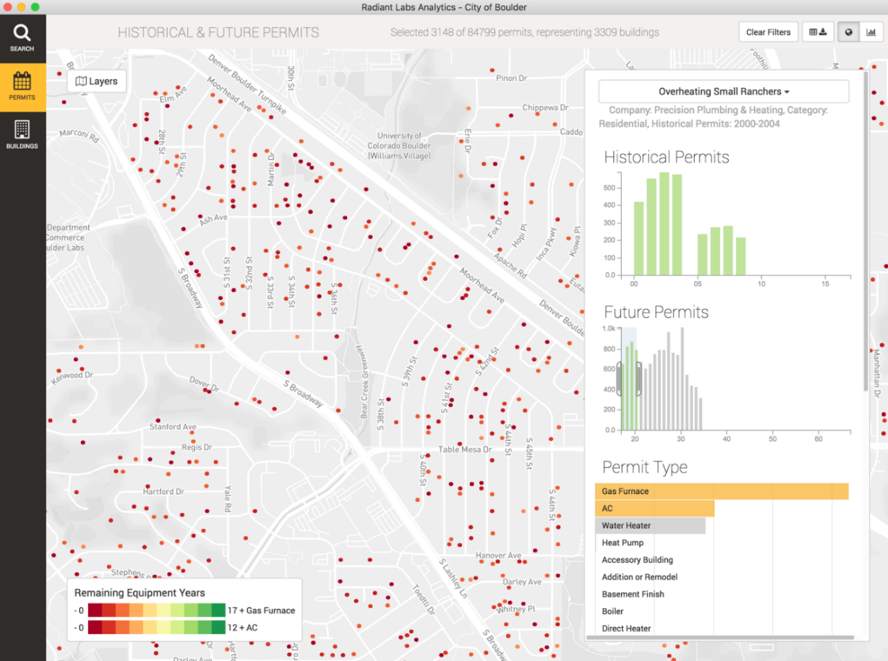

Consumers who have previously participated in energy efficiency programs may be more open to adopting a new technology, particularly when there are incentives. Aside from those who care about the environment, early adopters may often be motived by cost or comfort concerns, either reducing heating costs in areas where natural gas is unavailable or replacing outdated and inefficient equipment. A survey of existing heat pump customers demonstrated a range of motivations for selecting heat pumps with the primary reasons as follows: efficiency, comfort, adding cooling, and utilizing with solar PV. The existing customers are not representative of the broader market of average homeowners in Boulder; however, they provide insight into the mindset of early adopters. Figure 2 provides a snap shot of 7 potential early adopter archetypes that can be input (via filters) into the Radiant Lab tool. The table below the figure shows how many Boulder homes currently exist in each early adopter archetype.

The total of all these archetypes is 19,785 homes, with over half of those being the “well to do progressives” who are in need of replacing their AC or furnace in next five years, within census block where median income is greater than $81,000.

Figure Early Adopter Cohort Example

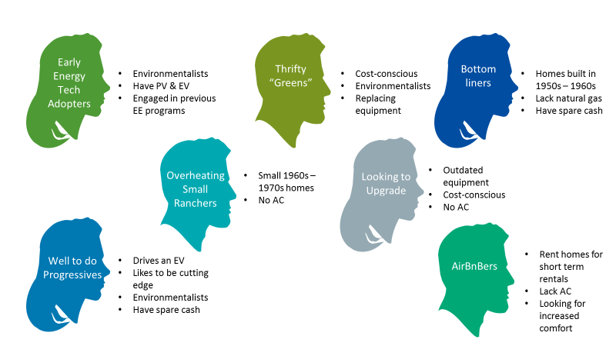

|  |  |
| --- | --- |
| **Early Energy Tech Adopters** (Early movers in energy action)  Criteria: Has Energy Smart upgrades, PV on the roof | **304 homes** |
| **Overheating Small Ranchers** (Small ranch houses built in the 60s-70s without AC)  Criteria: Likely lacks AC, home under 2,500 sq ft, built in 1960s-1970s, owner-occupied | **3,309 homes** |
| **Well-To-Do Progressives** (Have spare capital, replacing equipment)  Criteria: In need of replacing AC or furnace in next five years, within census block where median income is greater than $81,000 | **11,047 homes** |
| **Cashflow Positive**  Criteria: Identified in Radiant Labs to be cashflow positive with efficiency upgrades and full net-zero PV | **604 homes** |
| **Thrifty “Greens”** (Price conscious environmentalists with a broken AC unit)  Criteria: Has Energy Smart upgrades, in need of replacing AC or furnace in next five years | **1,691 homes** |
| **Landlords with Small Units**  Criteria: Home under 2,500 sq. ft., standard rental classification | **2,461 homes** |
| **AirBnB Requiring Air Conditioning**  Criteria: Likely lacks AC, in need of replacing AC or furnace in next five years, short-term rental classification | **369 homes** |

### **3. Iterative targeting refinement**

Radiant Labs also has an iterative adoption and refinement approach that helps an efficiency program regularly course correct. This process requires three major steps:

1. **Define a Cohort:**

Select a group of homes with common characteristics using the predefined archetype filters or any combination of filters that you plan to track over time, such as the archetypes named above. When that group of homes is ready to be tracked, save the chosen set of filters as a cohort. That will assign each home within the group a cohort ID, which will allow each house to be tracked over time as well as the aggregate performance of the entire cohort. The cohort characteristics will allow outreach and messaging to be tailored to the home. Then the entire cohort can be downloaded in CSV format, showing permit number, assessors number, owner name, address, description of the work, and category.

1. **Track home progress:**

In Colorado, all energy audits performed through Xcel Energy’s subsidized audit program utilize Snugg Pro (energy auditing software developed by Snugg Home, a sister company to Radiant Labs) to capture data and perform energy modeling. Participating contractors will utilize Snugg Pro to perform the necessary energy modeling to calculate system sizes, PV production requirements, and calculate the energy savings from the proposed improvements. This data will be used to create the formal proposal in the **homeowner roadmap tool,** which shows complete home energy transition step by step through options in 4 categories: 1. Energy Efficiency, 2. Electrification of Heating and Cooling, 3. Solar PV, 4. Electric Vehicle.



Once the work is completed, the actual improvements will be recorded by the contractor into Snugg Pro and a new energy model will be performed. The resulting modeled energy usage will be captured in the Radiant Labs software and stored with the original home data. If a household does not move forward with the upgrades a survey is conducted to find out the barriers and reasons for the inaction. This data will be recorded in the Radiant Labs database by an energy advisor or contractor.

**3. Define and refine cohorts**

Improved pre- and post-retrofit data will facilitate the refinement of outreach and messaging strategies to be used. To refine cohorts the process is: 1. load the original cohort, 2. review the statistics on which homes got upgrades, 3. review any barriers to upgrades in that cohort for those who took no action, 4. adjust the filters to create a cohort with a better conversion rate by changing the filters to reflect the new data received.

Some cohort attributes which depend on market factors will change over time. Some of these factors include price per kWh, price per watt of PV, and carbon mix on the grid. It’s easy to add or remove homes from the cohort based on these updated market factors. Once this updated cohort is ready, it can be saved as a revision to the original cohort or added as a completely new cohort.

# 4 leverage market analysis to engage key stakeholders and develop policies & programs

Leveraging the results of the market analysis to support the development of policies and programs to encourage adoption of RH&C technologies is critical to the success of a thermal decarbonization initiative. This section discusses some potential policy and program actions that city leaders could consider to build on or in conjunction with the market analysis.

Note that as of the end of 2017, the four cities who completed their respective market analyses are in the process of implementing next steps to build on the results of their analyses. Actions that these cities are considering or are implementing are thus provided here as opportunities that could be pursued by city leaders as opposed to best practices that have been tested in a variety of jurisdictions.

At a high level, policy and program opportunities could include the following:

**Assess local barriers and opportunities**

As part of the process of identifying policy and program options, consider assessing the local barriers and opportunities for RH&C deployment. While these barriers can be broadly grouped into several categories (e.g. economic, technical and building, policy and regulatory, awareness, decision-making, supply chain), it is important to identify specific, prominent local barriers and evaluate how these barriers will affect the potential for impact from policies and programs in your city.

**Map the local RH&C supply chain**

In addition to increasing customer demand for and adoption of RH&C technologies, it will be critical to simultaneously grow the industry supply chain in order to ensure there is a sufficient number of high-quality contractors in the market to meet growing demand. Understanding key actors in the industry supply chain—e.g. manufacturers, distributors, installers, designers, etc.—will be critical to successfully engaging them in city programs. Importantly, while manufacturers and some distributors are national, most contractors are local, and it will be important to ensure that local contractors can benefit from the growth in RH&C installations that will be driven by city programs.

Mapping the local supply chain can be a first step to directly engaging industry actors. In particular, it can be valuable to city leaders to understand the total number of HVAC contractors and distributors/suppliers active around the city as well as those who are offering RH&C-related services and equipment in order to understand the degree of industry engagement and growth that will be necessary to meet growing demand.

Additionally, it can be valuable to understand the types of RH&C-related trainings and certifications offered by manufacturers, distributors, and third-party organizations, as well as how readily available those certifications are to contractors interested in installing and servicing RH&C systems (i.e. what distributors or training centers are offering these trainings and where are they located). It will be critical to ensure that new contractors entering the market are adequately trained to ensure that the growing number of RH&C installations are not poorly-installed, which could negatively impact growth in the market.

For example, the typical residential ASHP and HPWH supply chain is shown in Figure 3 below. As part of the project, the four cities completed a supply chain mapping exercise focused primarily on cold climate ASHPs to better understand the industry actors active in their cities.

Figure . Typical ASHP and HPWH residential supply chain

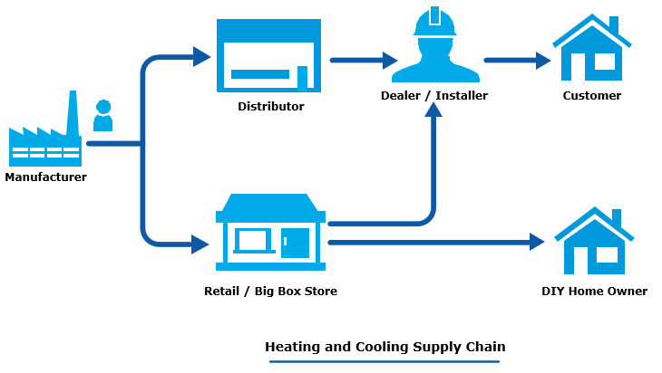

**Explore options for policies and programs**

A broad suite of policies and programs will be necessary to achieve a city-wide market transformation. Some of the high-level categories and examples of policy actions identified by the project team and in other jurisdictions are described in Figure 4.

Findings from the market analysis can be leveraged for some of these policies and programs. For example, programs aimed at raising outreach and encouraging technology adoption could be focused on key market segments or cohorts identified as likely adopters in order to drive initial success and build momentum for follow-on actions.

Example options for policies and programs to drive RH&C adoption.

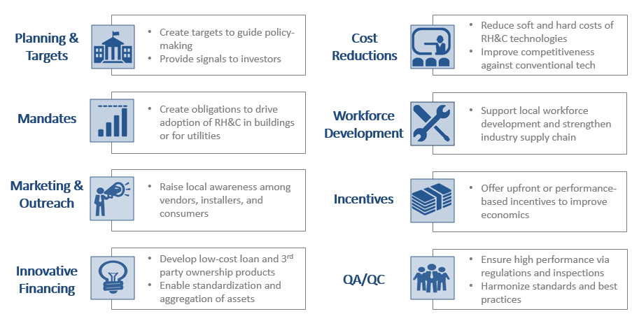

As cities are limited in their capacities (e.g. staff, financial) and areas in which they can influence, cities could consider as a starting point pilot programs focused on raising awareness and building customer demand, voluntary mandates and codes for RH&C, and other actions to stimulate initial market demand. Additionally, cities should consider their options for engaging and influencing state- and utility-level decision-making processes to address issues outside of their spheres of control.

**Explore collaboration with a broad range of key stakeholders**

Driving a market transformation on the scale needed to achieve deep decarbonization goals will be challenging and will require coordinated efforts from various key stakeholders, ranging from industry actors (e.g. manufacturers, contractors, distributors) to local community organizations to state policymakers/regulators and utilities.

City leaders could consider conducting stakeholder mapping exercises to identify key stakeholders, influencers, and decision-makers that could strengthen (or inhibit) city efforts. These stakeholders could be engaged as part of a stakeholder advisory committee in order to solicit input and form strategic partnerships related to city thermal decarbonization actions.

In particular, the four cities have expressed significant interest in directly engaging and establishing public-private collaborations with leading manufacturers of heat pump technologies in order to coordinate efforts and collaboratively drive market development. The cities have begun engaging manufacturers through convening and follow-on pilot projects. Details on these efforts and lessons learned from working to establish these collaborations are discussed in Box 2.

Box . Establishing public-private collaborations: experiences from fostering collaboration between core cities and heat pump manufacturers

|  |
| --- |
| Achieving the deployment of RH&C technologies necessary to meet city climate goals will require a massive market transformation. To date, growth in RH&C adoption (especially ASHPs) has been promising in certain jurisdictions but not yet adequate to meet these goals. Given the scale of the challenge, it is likely that city actions alone will be inadequate to drive the market growth necessary.  As part of their thermal decarbonization projects, the four cities have been exploring opportunities to directly collaborate with heat pump industry actors to drive market development initiatives. To date, this engagement has focused on leading manufacturers of ASHPs and HPWHs. As described in Figure 5 below, cities and manufacturers have a variety of complementary strengths that can be leveraged to address the challenges each faces in seeking to drive the market, affecting policymaking outside their spheres of control, and competing against incumbent fossil fuel interests.  Figure . Complementary strengths between cities and manufacturers    A focus on establishing public-private collaborations is not new within the renewable energy sector: the remarkable, explosive growth in solar PV deployment has been driven with support from high-level public-private collaborations between federal/state governments and the private sector to drive innovations and cost reductions (e.g. the U.S. Dept. of Energy’s SunShot Initiative). Similar collaborations at the local level could serve to build momentum for market development initiatives and provide necessary technical assistance to support city initiatives.  Since 2016, the four cities have undertaken several actions to facilitate the establishment of public-private collaborations to drive market development:   * **Going to Scale 2016.** In September 2016, the Rockefeller Brothers Fund convened a “Going to Scale” summit in New York City. Led by the four cities as well as Boston and San Francisco, this summit was attended by representatives from nine leading ASHP and HPWH manufacturers, as well as foundations, non-profits, and consultants. This summit focused on pathways to achieve deep decarbonization in the heating and cooling sectors and discussed opportunities for collaboration and market development. * **Thermal Decarbonization Initiative – Phase 2.** In September 2017, the four cities were awarded a grant from the Carbon Neutral Cities Alliance (CNCA) to build on work completed in this project to design and/or implement pilot programs to grow customer demand, engage the industry supply chain, and foster development of new partnerships with key stakeholders. As part of this project, the four cities will directly collaborate with Mitsubishi Electric to test opportunities for working with manufacturers on designing and implementing market development initiatives. * **Going to Scale 2017.** In October 2017, the Rockefeller Brothers Fund convened a second annual “Going to Scale” summit in San Diego. In addition to the six cities who participated in the 2016 summit, the 2017 summit was attended by representatives from eight manufacturers, 11 additional cities, 11 foundations/non-profits, and 2 state/federal agencies. This summit focused on providing an opportunity for leading cities to share updates on progress to date and discuss best practices and next steps for city action; exploring specific opportunities, barriers, and ground rules for establishing collaborations between public, private, and non-profit entities to drive joint market development initiatives; and discussing needs and considerations for developing a nationwide technical assistance platform for supporting city initiatives and facilitating collaboration between stakeholder groups.   Going into 2018, the four cities will continue to design and implement pilot programs as part of the CNCA grant, as well as build on momentum from the October summit to mobilize a broader network of cities and manufacturers to build a broader nationwide platform for supporting local market development. |

1. As an immediate follow-up to this work, the four cities received grant funding from the Carbon Neutral Cities Alliance to develop Phase 2 of the “Thermal Decarbonization Initiative.” To facilitate public-private partnership formation and support additional observer city network development, the Project Team convened the “Going to Scale: City-Industry Cooperation for Renewable Heating and Cooling (RH&C)” in October 2017, which was attended by representatives from 17 cities, 8 heat pump manufacturers, 11 foundations and non-profits, 2 state/federal agencies, and other supporting consultants.
2. In particular, under current market conditions, heat pump technologies are not cost-competitive against natural gas. While heat pumps can offer additional benefits to the community beyond GHG reductions (e.g. improved indoor air quality, access to cooling), under the current policy landscape (e.g. no carbon pricing, incentives for natural gas conversion and extraction) and economic conditions, thermal decarbonization of gas-dominated cities will be challenging. To date, most heating-focused installations of heat pump technologies have typically focused on customers using higher-cost heating fuels (e.g. oil, propane, electric resistance).
3. For more information, see: Synapse Energy Economics and Meister Consultants Group. (2017). Northeastern Regional Assessment of Strategic Electrification. Prepared for the Northeast Energy Efficiency Partnerships.
4. NYC 80x50 Roadmap.
5. Find DNV GL Permit study: [energydataweb.com/cpuc](http://energydataweb.com/cpuc)